MarKamusic - Zampoñas (panpipe) Workshop

Historical Notes:

The Zampoña [Sahm-póhn-yah] (panpipe) is a generic term for a family of wind instruments each consisting of a collection of thin bamboo tubes strapped together in a form similar to East-European Pan-pipes, which are usually made out of wood. Wind instruments similar to the Zampoñas exist worldwide. In Indonesia, Hawaii and the Polynesian Islands there are a variety of pipes that are blown in order to produce sound and music. The South American Zampoñas are most successfully constructed when made out of a kind of bamboo plant, which possesses long stems with broadly spaced nuts. This characteristic makes this specific type of bamboo the most appropriate for the creation of Zampoñas. The space between nuts is particularly important in the making of the 6 foot Toyo because it would be quite problematic if the reeds had nuts separated by less then 6 feet. There are about 400 different kinds of bamboo plants around the world but only a few varieties are suitable for making these pipes.

The Zampoña family ranges in sizes from the tiny Chuli (about 4.5’’) to the six-foot long Toyos. The Zampoña is the oldest of the South American indigenous flutes. It is believed that as early as 5000 years ago this instrument was used in its pentatonic form. It was not until the arrival of the Europeans that the Zampoñas acquired their most common, present-day tuning in G. Some ethnomusicologists believe that the name of this family of instruments stems from a mispronunciation by the Indians of the word symphony (sinfonía in Spanish). The author of this workshop also believes it likely that the “Symphony” effect produced by a troupe of Zampoñeros, usually consisting of more than forty players playing Zampoñas of all different sizes, may have influenced the Spanish conquistadors and colonists to call the Zampoñeros a “Symphony.” The musical effect would have reminded Europeans of the “Symphony” orchestras that they were accustomed to back in Europe.

Other members of the Zampoña family employ various sizing to produce different tuning arrangements. These include: Maltas, Bastos, Toyos and Semitoyos (in Bolivia), Sikus, Antaras (in Peru), Rondadores and Payas (from Ecuador). The array of chosen names are in accordance with the instruments’ regions of provenance. In the Andean mountains you can often see pairs of Zampoñeros playing alternate notes in rapid succession resulting in a kind of "stereo" effect. Traditionally, two individuals divide the Zampoñas into two separate rows of pipes so that while one of the players is “breathing” the other player is playing and vice versa. A great degree of synchronization is required of the players to successfully accomplish this activity.

The Indians probably devised the playing of the instrument in this fashion due to the high elevations of the Andean Mountains in which they live (at an average of 16,000 feet). At such extreme altitudes, where the air is “very thin” (low concentration of oxygen), a single player could rapidly hyperventilate while playing the instrument. The division of playing between two players also correlates with the values of the Indian societies. For Andean Indians, every aspect of life and existence are marked by a communal attitude. In such a rugged environment, the sense of community is integral to their survival.

Materials:
The materials necessary for this workshop are quite accessible. Most items can be found at your local hardware store.
- Cork wide enough to fit very tightly the PVC pipe.
- Elmer’s Carpenter Glue.
- Duct Tape. (packing tape and wide scotch tape are also usable)
- One Quartz-Digital chromatic tuner (a guitar tuner would do too)
- Fine Sand Paper
- 13 Lengths of 1/2” CPVC pipe (for hot water is best). You can buy one CPVC pipe that usually comes in lengths of eight to ten feet and then use a tube cutter or a hacksaw to cut it according to the following measurements:
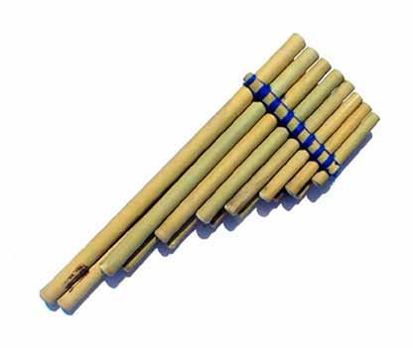

Pipe # | Length | Tuning
1 | 3 ¾’’ | B
2 | 4 ¼’’ | A
3 | 4 ¾’’ | G
4 | 5’’ | F#
5 | 5 ½’’ | E
6 | 6 ¼’’ | D
7 | 7’’ | C
8 | 7 ¼’’ | B
9 | 8 ¼’’ | A
10 | 9’’ | G
11 | 9 ½’’ | F#
12 | 10 ¾’’ | E
13 | 12 ’’ | D

- If you would like to make a panpipe like the originals you may try to look for a Bamboo gardening stick. Bamboo sticks can be found in gardening stores. The same measurements that you use for the CPVC pipe according to the measurements in the table.
- After you cut the pipe you must number each piece according to the table.
- Sand smoothly both ends of all pipes (you will have to place your lips over these).
- Close one end of each piece of pipe with a glued cork.
- While the glue is wet, blow on the pipes and check their tuning with the tuner.
- If pipe is too sharp you will have to pull the cork out a little.
- If the pipe is to flat you will have to push the cork in until it reaches the desired note.
- Using your chromatic tuner, you will need to make the pipes correspond to the following notes while blowing into them: 1 to B, 2 to A, 3 to G, 4 to F#, 5 to E, 6 to D, 7 to C, 8 to B, 9 to A, 10 to G, 11 to F#, 12 to E, and 13 to D.
- When all pipes are tuned, let glue dry completely.
- Arrange all pipes on a flat surface in two groups and in ascending size: 1,3,5,7,9,11 and 13 (this row is called the ARCA) in one group and 2,4,6,8,10 and 12 (this row is called the IRA) in another group. When you have finished laying out the pipes, you should have one row with seven odd numbered pipes and another row with six even numbered pipes.
- Arrange both groups of pipes so one end of each group is all leveled flat and the other end looks like stairs.

Bound both groups very tightly with duct tape. If possible, just with one strand of duct tape.
- You must place your Zampoña with the largest seven-pipe row in the back and the six-pipe row in the front.
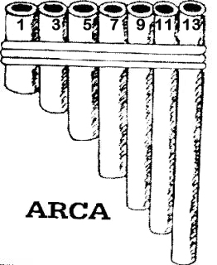
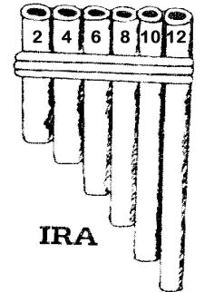

How to play your Zampoña:

You need to hold your Zampoña facing you and a little higher than your chin. The smallest pipes must be on your left (opposite to what western music would suggest, where you would have the highest notes –smallest pipes- on your right).
You must play your pipes by placing them next to and under your lower lip while trying to direct the blown air “inside” the pipe not across the top. The blowing technique is very much like when you blow across a Coca Cola bottle.
To control the flow of air that produces sound you must use your tongue to cut the air, almost as if you were going to spit. This also will help you when you are playing staccato (short and pronounced) notes. If you blow across the top of the pipes you get an interesting, airy sound/effect.
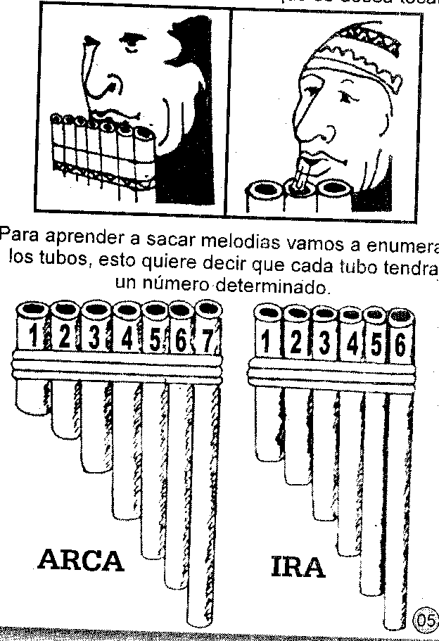

You must position the Zampoña right under your lower lip.

