
MarKamusic

Introduction
If you've ever blown across the top of a bottle and managed to produce a note you should be able to play an Ocarina. An Ocarina is a musical instrument which is based on the same principle. To produce sound, you blow into a windpipe which directs your air across a beveled edge. Air leaves the instrument through a whistle head, similar to that found on the mouthpiece of a recorder. The range of an ocarina is determined by the number and size of its finger holes.
Some people claim that the first one was made towards the end of the nineteenth century by an Italian named Giuseppe Donati. He actually designed a small ceramic vessel which looked like a Gosling - hence the name 'Ocarina' which is Italian for 'little goose'. The reality is that ocarinas are quite common to many areas of the world and have existed for thousands of years made out of clay, ceramic and animal or human bones. Vessel flutes were first used by pre-contact Native societies in Latin America, especially in the regions of Costa Rica, Colombia, Guatemala, Panama and Peru. Made from clay or beeswax, these flutes had four or fewer finger holes, and were often in the shapes of human beings or animals. Elaborately carved ceramic flute effigies (for example, a human face peering through the open jaws of a tiger) have also been found in the Tairona region.
There is also a traditional South African instrument called a 'shiwaya', made from a fruit shell which has been dried and hardened in the sun. All such instruments involve blowing across one hole and covering others to make different sounds. They became very popular in Europe and the general name of 'Ocarina' is now used to refer to all types of 'globular flutes'.
These pages will show you how to make an Ocarina from card stock. The shape of the Ocarina is based on an 'Icosahedron', a geometric solid made from 20 equilateral triangles. You can design your own from other geometric solids. Smaller sizes will produce high notes and large ones low notes. The length of side on this Ocarina is 45mm. For a Soprano Ocarina try between 25mm and 30mm side, Alto between 35mm and 40mm and Tenor between 45mm and 50mm.

Materials to Build your Ocarina
To make the Ocarina you will need:
- A sheet of thin card stock
- A pair of scissors
- A craft knife
- Paper glue
- A steel safety ruler
- A cutting board
Cutting the pattern out of the card

If you haven't already done so, print out the pattern page for the Ocarina. Make sure your printer will take thin card stock otherwise print the pattern on plain paper and then glue the paper to a sheet of card stock. Choose good quality card stock.
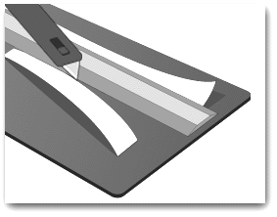
Use a sharp knife against the steel safety ruler on a cutting mat whenever possible. Blunt blades do not cut properly and take too much pushing through the material. Keep fingers always behind the cutting edge and don't press too hard. Several gentle shallow cuts into card will often produce better results than attempting one heavy cut.
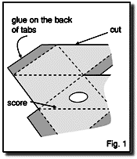
Scissors can be used for paper and thin card but will tend to distort heavier card. A good sharp knife is usually best. Replace blades often and test for sharpness by cutting scrap paper.
Carefully cut out along all the solid lines and score along the dashed lines as show in fig. 1. Fold all the score lines very carefully so that the model folds up with the printed pattern on the inside. Use glue or double sided tape to assemble the shape by matching the letters - it may help to position some flaps by poking a rod or a pencil through the finger holes.

Assembling the Mouthpiece

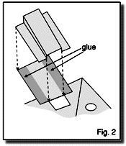
Assemble the mouthpiece as shown in fig.2. Make sure all seams are properly sealed. Leaky seams can cause the Ocarina to go out of tune or not sound well. Card models will last much longer if once you have finished you completely varnish it.

Once you have finished making your Ocarina look for the “Playing your Ocarina” section on how to learn to play it.

Folding the card stock

To fold the thin card stock, lay a ruler along the edge to be folded up. To form crisp, firm creases cover the folded card with a clean piece of scrap paper and burnish with a smooth surfaced ruler. Always pre-crease and fold everything before attempting to glue it. Try out the best assembly sequence dry before applying adhesive.

Gluing

Elmer’s glue or rubber cement can be used on bare card stock, but cards with a glossy surface will often require a solvent based adhesive or adhesive tape. A water based contact type adhesive is available however and this is safer to use. Use a scrap of paper to mask off when brushing glue on to tabs. Glue one
flap or tab at a time if possible. Don't over-glue, allow for the bead of glue to creep out when squeezed.

When joining an edge to a surface, use a cocktail stick or toothpick to trail a bead of glue along the contacting edge. Use clothes pegs, bulldog clips, weights, rubber bands or masking tape to support the joint until the adhesive dries.

Playing your Ocarina

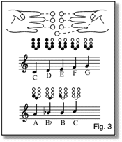
Cover all the holes of the Ocarina to play the lowest note and then remove fingers one at a time to play an increasing scale. Make sure the holes are sealed completely and blow reasonably hard. It sounds better if you can tongue - as if you were saying “T” at the start of each note.

The fingering diagram shows how finger positions relate to the notes. The thumb position is at the bottom. If you want to play a major scale, leave out the 'b-flat'.

More accurate tuning can be achieved by fine-tuning the sizes and positions of the finger holes. Experiment by partially blocking off holes with sticky tape. To check the accuracy of the intervals between the notes, use an electronic keyboard as a reference as these can usually be very easily tuned to any pitch.

Once you've mastered the scales try playing the piece of music below.

