Music from the
heart of
Latin America
MarKamusic

The myth
and the magic,
the music and
the mysticism,
reaching out
to the wandering
cathedrals of our thoughts.
The heat and
the mystery,
ever so powerful, romantic, danceable and soulful
MarKamusic
weaves an entrancing breath of sounds
and colors from the halls of modern and ancient souths.
The MarKamusic ensemble appeals to our collective musical memory from the soul
of persevering
Caribbean sands, supple Rain Forests and Andean plateaus.

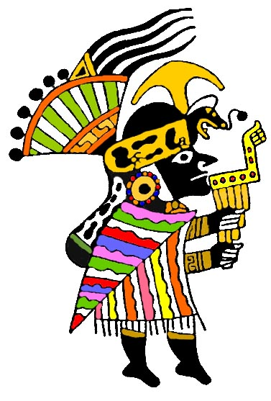

www.markamusic.com
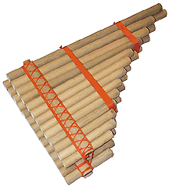

MarKamusic

From the windy barren high plateaus of the Andes, the mystical Amazon and Caribbean rain forests and the desert coasts washed by the Pacific and Atlantic oceans comes a high-energy, multi-national musical ensemble that performs music deeply rooted within the folkloric, pop and traditional genres of Latin America and the South American Andean regions.

MarKamusic musicians sensibly render the musical forms and the soulful art of the cultures and countries from the south. The resulting product is an ever changing, eclectic weave of ancient, modern, aboriginal and popular themes performed on a fascinating array of more than 40 native-indigenous, western and African influenced instruments.

Like their ancestors before them MarKamusic musicians draw from the depths of their unique cultural past: Inca, Maya, Quechua, Taino, West African, Aymara and Iberian /European. MarKamusic embraces musical history but then takes it to an altogether different place. Fused with the feelings and creations of younger generations, during its performances and workshops, MarKamusic emphasizes the musical and cultural contributions of the four major influences that have shaped modern Latin American music at large: the indigenous, the West African, the Iberian, and the United States. Traditional rhythms and musical forms from these diverse cultures slowly fused over the centuries, creating today's Latin American traditional, folk and popular musics. MarKamusic's careful choice of repertoire and instrumentation conveys this historic evolution to the audience. Deeply moving and full of fresh and ancient energy, MarKamusic’s songs call out to the senses of our collective human memory and to the doors of our ancient hearts. A sense of unity is evoked among listeners as they share the enchanting musical journey of MarKamusic.

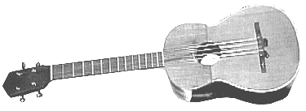

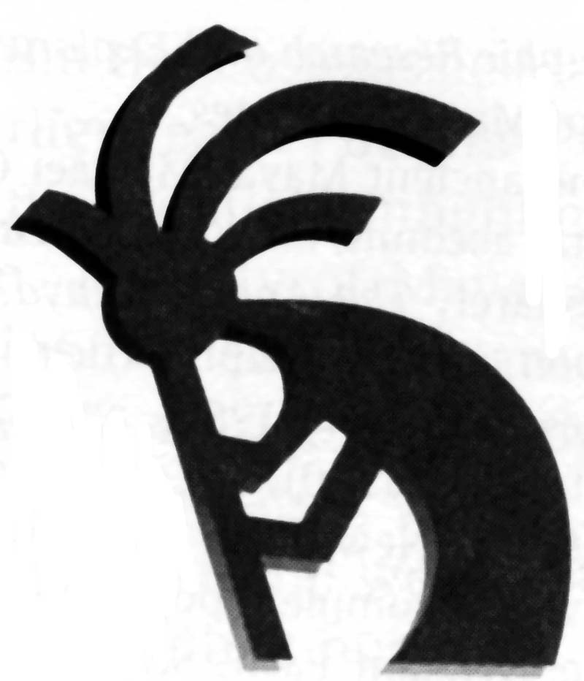


MarKamusic Goal


MarKamusic’s goal is to debunk western stereotypes of South and Latin American music and culture at large. By sharing the many musical gifts of these lands in their purest forms as well as blended with newer, hybrid creations of subsequent artistic and historic musical developments, MarKamusic portrays the vast cultural wealth of these regions in a cornucopia of musical knowledge. In the United States, profit interested groups have purposely created an aura of mysticism and mystery around the Latin American music genre and its people. Their efforts, geared to maximize the genre’s consumption and thus their own profitability, have misinformed North American audiences about the poise, representation, performance, accuracy and content of Latin American music. In combination with North American’s increasing interest in cultural diversity, North American audiences have been deceived into accepting profit-motivated, prepackaged products. MarKamusic treats these exquisite musical traditions with the care and love fostered by our own ancestral roots and hopes to share with listeners the enriching recognition that America is larger than the United States; that America in fact stretches from the state of Alaska down through the tip of Tierra del Fuego.
For more information please call: 413-549-9155

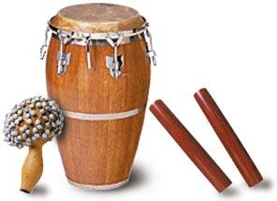

The members of MarKamusic feel that our multiplicity of cultures tied by history and geography but separated by politics, race and language can most effectively be reconciled by the sharing, indeed, the merging, of our musical-artistic expressions.
MarKamusic musicians strive to embody the potential for this harmonious exchange by drawing on the talents and resources of one Peruvian, one Ecuadorian, three Puerto Ricans and one Guatemalan.


MarKamusic Instruments
MarKamusic performs on over forty familiar and exotic instruments to create the unique musical textures, tonalities and colors of the many lands and cultures in the Latin American continent. These instruments are the product of native aboriginal musical craft traditions, which have evolved over millennia, as well as from African, European, and North American sources, which fused with the indigenous instruments to create new hybrid versions of old instruments:
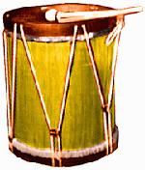
Wind Instruments:
Zampoñas (Chulis, Maltas, Bastos), Rondador, Quenas, Tarkas, Silver Flute, Concha, Pututo, Ocarinas, Toyos, Antaras, Sax, Bamboo Sax, Bird Callers, Wind Makers, Pinkillos, Toyos, Pan Flute and Quenacho.
Percussion Instruments:
Congas, Bombo Legüero, Bongo, Kit Drums, Quijada, Tortuga, Peruvian Cajon, Claves, Ganza, Maracas, Cowbells, Timbales, Rain Sticks, Chajchas, Bamboo Chimes, Sea Shell Chimes, Wave Drum, Shakers, Hüiros, Croak makers and Key Chimes, Thunder drum, Dominican Tambora.
String Instruments:
Spanish Guitar, Colombian Tiple, Venezuelan Cuatro, Charango, 12 Steel String Guitar, 6
String steel guitar, Electric Bass, Piano and
Ronroco.

For more info. please contact:
Freddy Chapelliquen
MarKamusic Management
12 Charles Lane, Amherst, MA 01002 USA
Phone: 413-549-9155
Email: Freddy@markamusic.com
www.markamusic.com
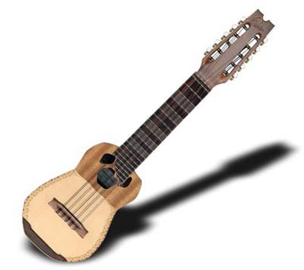

MarKamusic has performed at:

-Providence Convention Center, Providence, RI
-Mountain Cultures Festival, Hunter Mountain, NY
-Cultural Organization of the Arts, East Greenwich, RI
-Berkshire Community college, MA

-W. Alton Joans Environmental Center, West Greenwich, RI
-Danbury First Night, Danbury, CT
-National Assoc. of Independent Schools Conference, Providence, RI
-New Sensation Night Club, Guatemala City
-Agnes Irwin School, Rosemont, PA
-UMASS Amherst, MA
-World Music Festival, Hunter, NY
-Ministry of Culture, Tegucigalpa, Honduras
-Hampshire College, South Amherst, MA
-Kennedy Center, Washington DC

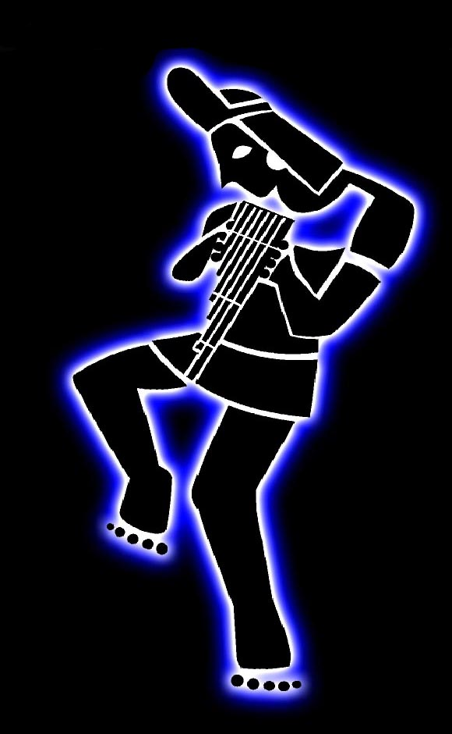
Fee Structure
We welcome the opportunity to discuss our flexible fees with you. Your distance from Western Massachusetts (Amherst), the length and number of the performance(s) and/or workshop(s), inclusion of accommodations, meals and sound system provisions will be considered. Because MarKamusic is fully committed to education, K-12 Educational Institutions receive a 40% reduction off the full MarKamusic concert fee.

Promotional Materials

If you require promotional materials we will gladly provide you with any of the following:
-Promotional Brochures like this one or 8X11 B&W trifold.

Workshops, Lectures, Seminars

and Residencies
MarKamusic offers workshops, residencies and developmentally appropriate educational presentations designed for grade levels ranging from Kindergarten - University settings, museums, organizations and other educational institutions or groups. These performance events are designed to broaden people’s cultural horizons and awareness of Andean and Latin American History, Art, Culture and Traditions. An extensive educational resource guide, prepared by MarKamusic member Freddy Chapelliquen, is available upon request in advance of the workshop(s) or educational presentation(s). MarKamusic offered workshops are:
Sounds of South America: A hands-on workshop that demonstrates and discusses how the earliest musical expressions were recreations of the aboriginal environment.
Interactive Concerts With or Without Discussions: Interactive discussions and performances that highlight the historical, cultural and socio-economic contexts that influenced and determined dance, instrument, music, rhythm and lyric production and development in the Americas.
Spanish class: An enriching multicultural and learning experience designed for a Spanish class, preferably for an advanced group. Can be tailored to other levels.
Academic lectures and Demonstrations: Expand on the historical and socio-political evolution of South America through the lens of its rich musical traditions.
Instrument Making Workshops: Making of zampoñas (Andean pan-pipes), wind makers, whistles, bird callers, paper Ocarinas, key Chimes, Hüiros and shakers.
Caribbean Rhythms: A succinct tour of Caribbean musics, rhythms and themes culturally and economically contextualized within the history of the Caribbean.
Latin Rhythms Workshop: Designed as an introduction to the rudiments of Latin rhythms. Ideal for a percussion music class or ensemble.

-Sound equipment and stage diagram requirements list.
-8 X 10 B&W promotional photographs.
-11X17 and/or 8X11 Color or B&W Poster masters
in Pdf, Jpeg, Publisher or Word file.
-Promotional CDs.
-Press Release for media in three different lengths.
-Promotional T-Shirts.
-Extensive curriculum materials/teacher guide.
-Mailing Lists (in Microsoft Access).

MarKamusic CDs
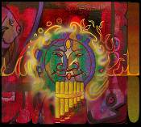
Acoustic Ancestor
A collection of contemplative and beautiful songs deeply rooted in popular, folkloric and traditional South American music.

Women And Children
An exhilarating musical voyage that showcases the variety, raw power and flare of Latin American music in a fascinating collection of instruments, rhythms and lyrics.

MarKamusic
A compilation of dazzling beauty highlighting the traditional and contemporary South American musical influences that characterize MarKamusic’s aural collage.

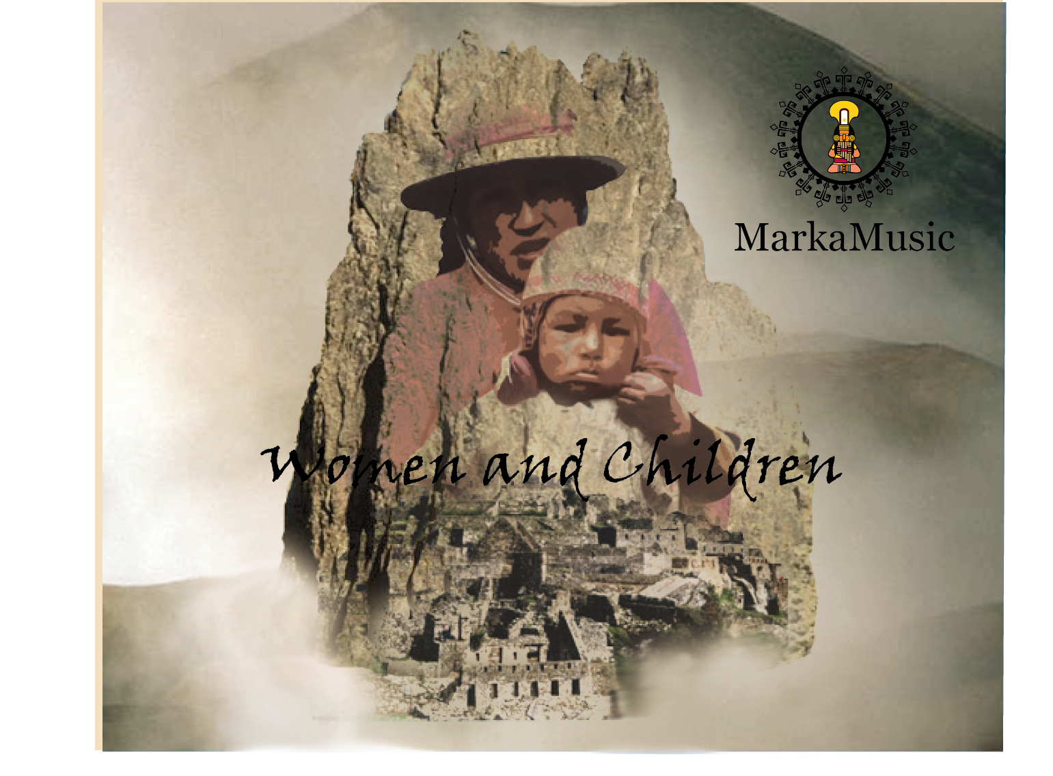

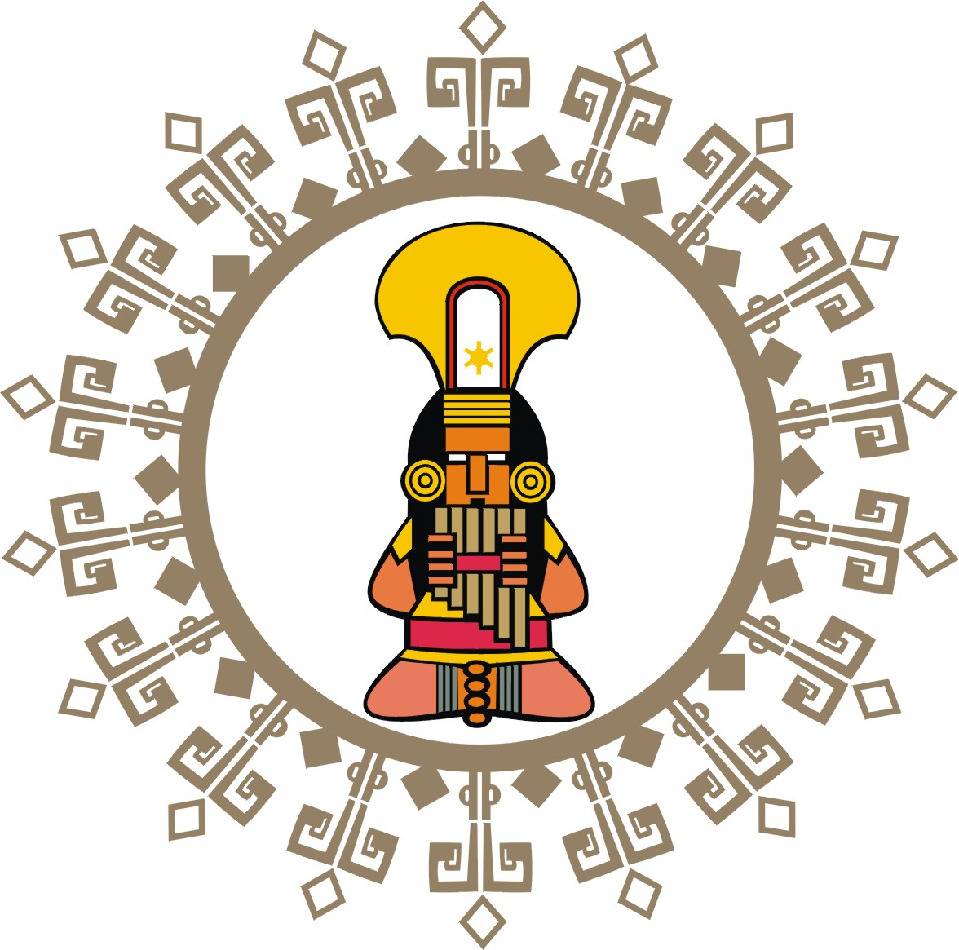
MarKamusic

For Additional Information:
Please log on to our web page to order Markamusic CDs
online or to find extensive information and links pertaining
to the Instruments, Music, History and Culture of the
Andes, South America and Latin America:
www.markamusic.com

