Minimum Sound System requirement List:
Sponsor must supply a sound amplification system consisting of no less than the following:

- 16 Channel mixer with two independent pre-fader, pre-EQ monitor mixes, each with it’s own equalizer. (we can deal with even one mix but two would be ideal)
- 4 monitor wedges distributed the following way:
- MONITOR MIX 1: 3 monitor wedges. All 3 across the front stage (left – center - right).
- MONITOR MIX 2: 1 monitor wedge. In the back between drummer and bass player.

- 10 microphones with stands, booms and respective cables:
- 5 vocal mics
- 2 overhead drum mics
- 2 Sm 57 (or equivalent for snare/hi-hat and congas)
- 1 kick mic

- 3 Di boxes (1 for rhythm classical Guitar, 1 for Bass Guitar, 1 for Venezuelan Cuatro).
- Main speakers and amplifiers according to size of audience with it’s own Equalizer, Reverb and Delay.
- Two power outlets on stage (one on left side of stage and one in the middle).
- FURNITURE: two small tables (2’x 2’), one straight back chair and two stools

Performer reserves right to bring it’s own sound engineer who will be accorded the authority to direct the equalization, sound effects and general mix of instruments and voices on mains and monitors as well as volume level of monitors. (Don’t worry, volume of mains is up to venue)

Stage Back

Julissa  - Conga Mic  - Vocal Mic (BK Vocals +  Panpipes)  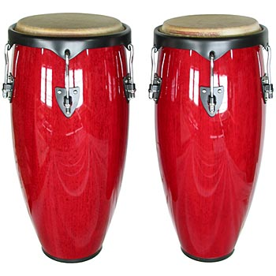  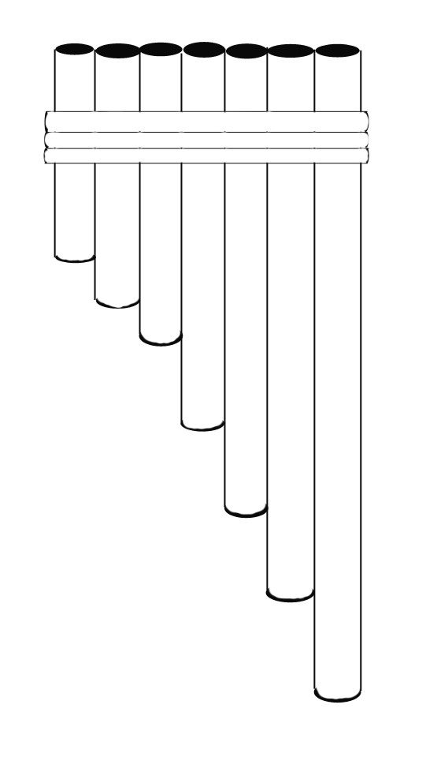 | Luis  -Drum Mics (Snare/HiHat, Kick,  Overheads L & R)  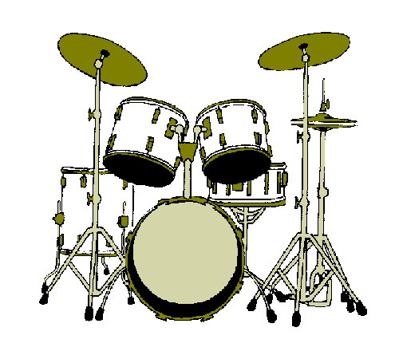   | Juan  - Bass Guitar Di  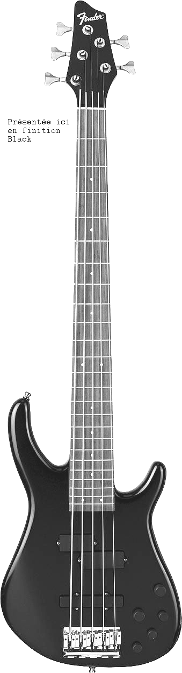  - Vocal mic (backing vocals)  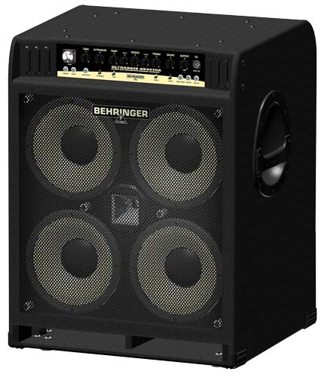  Monitor Mix 2
Freddy  -Vocal Mic (Lead vocal)  - Classical Guitar Di  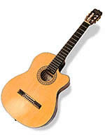  - Cuatro Di  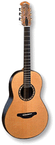    Monitor Mix 1 | Ahmed  - Vocal mic (flute & backing vocals)  - Assorted Percussion  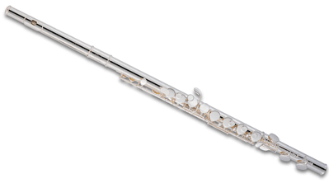  Monitor Mix 1 | Sergio  - Vocal Mic (Backing  vocals)  - Lead Classical Di  - Electric Guitar (mic)  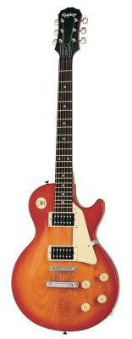  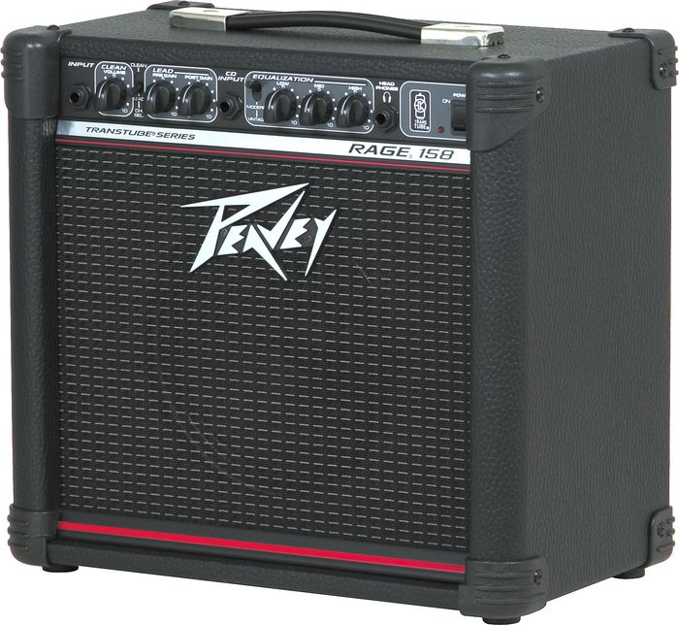  Mon Mix 1

Stage Front

MIXER LAYOUT:

Note to sound engineers: You will be working with 11 open microphones, mixing a good number of acoustic instruments, drums, interesting/unique string instruments (Cuatro), airy flutes (such as the Zampoñas/pan pipes, Quenacho, or quenas) and many different sound textures and timbres. In short, we understand that it may be difficult and interesting for you to mix this band.

CH | Instrument | Mic/DI | Monitor Mixes  1 2 |  | Comments
1 | Freddy Vocal | MIC | ☻ | ☻ | Lead Vocals and panpipes
2 | Ahmed Vocal | MIC | ☻ | ☻ | Silver flute and Background Vocals
3 | Sergio Vocal | MIC | ☻ |  | Background Vocals
4 | Juan Vocal | MIC | ☻ |  | Background Vocals
5 | Julissa Vocal | MIC | ☻ |  | Background Vocals and panpipes
6 | Electric Guitar | MIC | ☻ | ☻ | Sergio
7 | Lead Classic Guitar | Di | ☻ | ☻ | Sergio
8 | Rhythm Classic Guitar | Di | ☻ | ☻ | Freddy
9 | Venezuelan Cuatro | Di | ☻ | ☻ | Freddy
11 | Conga | MIC | ☻ | ☻ | Julissa
12 | Bass Guitar | Di | ☻ | ☻ | Juan
13 | Kick | MIC | ☻ | ☻ | Luis
14 | Snare/Hi Hat | MIC |  |  | Luis
15 | Overhead/left | MIC |  |  | Luis
16 | Overhead/right | MIC |  |  | Luis
17 | Reverb
18 | Delay/chorus

Important Info for main mix:

When Panpipes will be played by Freddy and Julissa, please be rather heavy on the reverb with just a touch of delay.
Cuatro needs to cut through the mix in the mains at all times.
Conga drum needs to be solid and cut through the mix (apply some high end).
Bass guitar and Kick need to have the bottom of a reggae bass but with definition.

