(Name of sponsor) represented by (sponsor's representative), hereafter known as the sponsor, contracts with the group MarKamusic hereafter known as performer, for a live performance as specified below, and under the following provisions:

Event:
Name of event:___________________________________________________________________hereafter referred to as “performance”.
Description of performance: (indoor concert, festival, nightclub show, private party, etc.) ______________________________________
Address of venue or performance site: _______________________________________________________________________________
Venue’s Phone #s:___________________________ (1),________________________ (2), Venue’s Fax #:_________________________
Representative’s Ph#s:___________________________(W), ___________________________(H), ________________________ ( Cell )
Date of performance (If contract consists of multiple performances, workshops or seminars, please include the whole schedule of performances as part of this contract):_______________________________ Start-time:________________End-time:_____________ Expected arrival time:_____________Access to stage:________________ No. of sets:_______________Length of sets:______________
No. of workshops:____________ Length of workshops:_______________ Theme of Workshops:________________________________

Rain/Snow date: _______________________Notification of cancellation in favor of rain date by:____________________________

Parking: Sponsor will provide close access of performer’s vehicles to the stage for loading and unloading for 20 minutes each time and legal parking for performer's vehicles during performance. If performer is expected to pay for parking, sponsor will be billed accordingly.

Sound System: Sponsor must supply sound amplification system in good working order, conforming to no less than the Minimum Sound System Requirements List detailed on pages 3, 4 and 5 included with this contract.

Courtesy: Sponsor will provide performer with 10 complimentary tickets, refreshments (please include juice, soda and water, ice and 10 cups), a private dressing area and snacks (may include: bread, cookies, cakes, sandwiches, cold cuts, fruits, cheese, etc. No fast foods please. Snacks will not be necessary if sponsor is providing a full meal -please see below).

Meals: If contract requires performer to be more than five hours at performance site (Including Sound System and musical instruments set Up Time), Sponsor will provide one full meal to performers and assistants (no junk or fast foods please).

Acommodations: Sponsor will provide performer with 4 double rooms and 2 full meals/day for a total of ________________ day(s).

Payment- Performance:$__________Travel:$__________Performer’s Sound System:$__________Total payment: $ .00
Please make all checks payable and addressed to:
- 30% deposit _____ weeks before performance date. 70% balance immediately after completion of performance(s)
- ________% of ticket sales (Ticket price: $_______ ) or a guaranteed sum of $______, whichever sum is greater.
- Payment to be made in full immediately before scheduled start time of performance.
Alfredo Chapelliquen, 12 Charles Lane, Amherst, MA. 01002-3801 /

(1)Performer reserves the right to perform a head-count.
(2)Performer reserves the right to sell their recordings and merchandise at the event site and retain all proceeds there from.

(3)Performer must receive sign contract plus 30% deposit ________ days before performance date.

Sponsor: Performer:
______________________________ _____________ Alfredo Chapelliquen ___________
Sponsor’s representative signature Date Performer’s representative signature Date
Please print your name:____________________________ Please print name: Alfredo Chapelliquen
Postal Address: __________________________________ Postal Address: 12 Charles Lane
_________________________________ Amherst, MA 01002
Email:_________________________________________ Email:Markamusic@comcast.net Web Page:______________________________________ Web Page: www.markamuisc.com
Phone #s:__________________(w)_________________(h) Phone #s: 413-549-9155 (w) 413-549-5855 (h)
Fax #:_____________________Cell:__________________ Cell: 413-433-0924

Required Information:
Travel directions from Amherst, MA to site of performance. (A map for the vicinity of the venue is required)

Travel distance:___________________________Travel time:_______________________Load-In time:_______________________

Performance Site Information:
Location of service or loading entrance to performance site:______________________________________________________________
______________________________________________________________________________________________________________
Permanent performer’s parking will be located at______________________________________________________________________
______________________________________________________________________________________________________________
Sponsor's representative/contact person at the site:_____________________________________________________________________
How/ where do we reach this person? _______________________________________________________________________________
His/her phone number/s: (work)_______________________ (home)_______________________ (cell)________________________
Size of the stage: _____________________________________ Capacity of venue:__________________________________________
Aprox. size of audience:________________make-up of audience (8th grade students, senior citizens, mixed, etc.)___________________
What is the occasion or context of the event/performance?_______________________________________________________________
Other Contractual Provisions:
Radio and television coverage- No audio, videotaping, broadcasting or cablecasting of this performance will be permitted without prior written consent from performer. Sponsor will be responsible for securing prior consent for audio and /or video taping, broadcast or cablecast by requiring that the sponsor, the broadcaster or cablecaster submit to performer, in advance of performance, a written notice that alerts performer of the fact and a) which affirms that two dubbed copies of the recording of the performance will be sent to performer by a certain date; b) which affirms that the recorded performance will not be broadcasted or telecasted more than twice within the current calendar year without prior written consent of performer; c) acknowledges that failure to comply with the affirmed will result in a charge of $5000.00 levied by performer upon sponsor and broadcaster or cablecaster. If unauthorized taping or broadcasting of performance described herein occurs without prior consent as previously described, performer will consider sponsor in breach of this contract (see Breach of Contract below).
Cancellation during event- In the event that performer properly arrives at performance site and cannot perform at agreed time, due to oversight or negligence of sponsor, or sponsor's employees, or sponsor’s representatives, due to (but not limited to) double-billing, scheduling error, breakdown of sponsor's equipment or technical facilities; delays or tardiness, acts of vandalism, fire drills, bomb scares, acts of terrorism, acts of God or for any other reason not the fault or mistake of performer, the performer reserves the right not to perform and sponsor agrees to make full payment herein agreed to performer regardless of whether performance described above was never or even partially performed. Once performer has downloaded sound system on stage, even partially, if sponsor decides to change the location of stage, for any reason whatsoever (rain, snow, or any kind of storms, acts of God, vandalism, bomb scares, acts of terrorism, poor decision making in choosing stage location, etc), sponsor will compensate performer with $500.00 extra than originally agreed for sound system rental. In the event that performer deems dangerous for its personnel, assistants and equipment (Sound System and Musical Instruments) to be set up, for any reason whatsoever. Performer will elect not to perform and sponsor will compensate performer for full amount of contract. In the event that performer cannot start it’s performance at agreed time due to sponsor’s delays of any nature, performer may elect at its discretion, a new starting time not to exceed 30 minutes from the original starting time. By signing this contract, sponsor agrees that Performer is not obligated to accommodate sponsor’s change of contractually agreed schedule. If time should be over 30 minutes, performer reserves the right not to perform and hold presenter liable for the whole amount of contract. By signing this contract, Sponsor agrees to be fully liable for the total value of performer’s sound system and equipment (which includes performer’s musical instruments) should damages occur to such equipment due to, but not limited to, sponsor’s or sponsor's employees and representative’s oversight or negligence, arising out of or in connection only with services performed under this contract. The time frame in which this clause applies extends from the very moment performer starts downloading their equipment and until all such equipment is back in the trailer/ bus/car uploaded in its entirety.
Cancellation prior to event- A performance cancellation by the sponsor – other than a weather cancellation - is considered “sudden” if it occurs_ 40__days or less prior to performance date. If sponsor cancels performance suddenly, the sponsor will forfeit the deposit previously paid to performer and agrees to indemnify performer for the remainder percentage of performance fee. If performer and sponsor have agreed that no advance deposit was required, the sponsor will be held liable for 100% of total performance fee.
Weather and Other Types of Cancellations- If performance is canceled by sponsor due to inclement weather, acts of God, acts of vandalism, acts of terrorism or any other reason, after contractually agreed time of notification of cancellation in favor of rain/snow date, or while performer is traveling to or is already at performance site, sponsor will pay performer in full regardless of whether program described above was never or even partially performed. In the event that a storm should develop while performer is at performance site, performer should decide if cancellation is advisable in lieu of the fact that equipment could be damaged.
Length of Contract- Sponsor agrees that performer is obligated to perform only within the contractually agreed time of performance. This predetermined time spans exactly from ‘’start time’’ of performance to ‘’end time’’ of performance as specified in the present contract, therefore performer will cease to perform exactly at contractually agreed ‘’end time’’ of performance. If a delay in the ‘‘start time’’ of performance occurs due to sponsor’s delays of any nature whatsoever, the ‘’end time’’ of performance will remain the same as specified in this contract. If sponsor expects performer to remain performing for extra time, a new contract should be signed on the premises to that effect.
Breach of contract- In the event that sponsor breaches any of the agreements listed in this contract, performer will not perform and hold sponsor liable for full amount of contract.
Liability- Sponsor will indemnify and hold harmless the performer against any and all liability, laws, damages, costs, or expenses for personal injury or damage to real or tangible personal property which the performer may sustain, incur, or be required to pay, arising out of or in connection only with services performed under this contract. Performer’s responsabilities are only to sponsor not to other parties with whom sponsor may have other agreements in connection with this event This contract will supersede, prevail and rule over all other contracts signed within sponsor and performer in connection with the previously named event/performance and it must be governed by the laws of the Commonwealth of Massachusetts.

Minimum Sound System requirement List:
Sponsor must supply a sound amplification system consisting of no less than the following:

- 16 Channel mixer with two independent pre-fader, pre-EQ monitor mixes, each with it’s own equalizer. (we can deal with even one mix but two would be ideal)
- 5 monitor wedges distributed the following way:
- MONITOR MIX 1: 3 monitor wedges. All 3 across the front stage (left – center - right).
- MONITOR MIX 2: 2 monitor wedges. One for Drummer and one for Bass player.

- 12 microphones with stands, booms and respective cables:
- 6 vocal mics
- 2 overhead drum mics
- 3 Sure 57 (or equivalent for snare/hi-hat and congas)
- 1 kick mic
- 4 Di boxes (1 for Classical Guitar, 1 for Bass Guitar, 1 for Charango, 1 for Cuatro).
- Main speakers and amplifiers according to size of audience with it’s own Equalizer, Reverb and Delay.
- Two power outlets on stage (one on each side of stage).
- FURNITURE: two small tables (2’x 2’), two straight back chairs and two stools

Performer reserves right to bring it’s own sound engineer who will be accorded the authority to direct the settings of mains and monitor levels, equalization and sound effects. (Volume and Level of mains is up to venue)

Stage Back

Rene  -Drum Mics (Snare/HiHat, Kick, Overheads L & R)  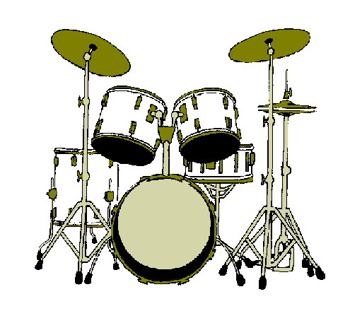  -Vocal Mic  Mon Mix 2   |  | Junior  - Bass Guitar Di  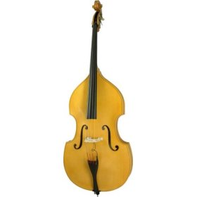  - Vocal Mic    Mon Mix 2
Freddy  -Vocal Mic (Lead Vocal)  -Guitar Di  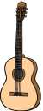  -Cuatro Di  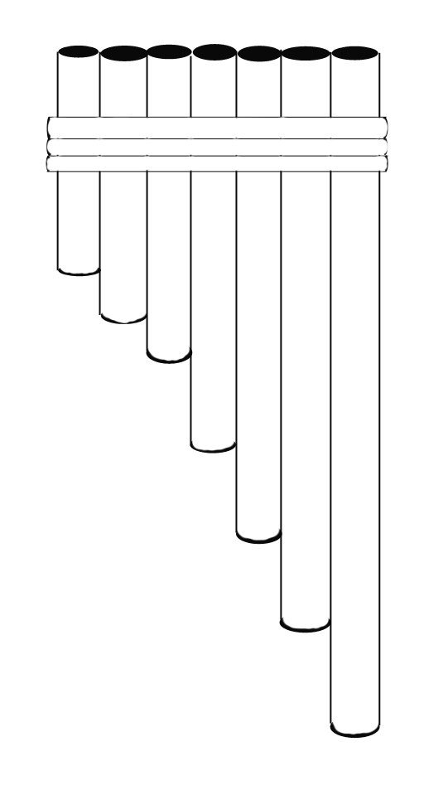  Monitor Mix 1 | Cesar  -Vocal Mic (Lead Vocal/panpipes) -Charango DI    Monitor | Jaime  -Vocal Mic (Vocals +  Panpipes)  Mix 1 | Ahmed  -Vocal mic (Silver Flute/ vocals) - Conga Mic  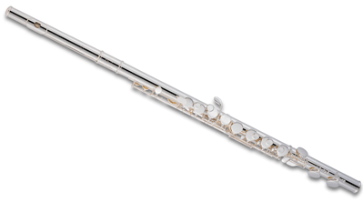  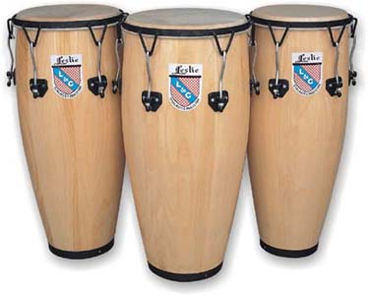  Monitor Mix 1

Stage Front

MIXER LAYOUT:

Note to sound engineers: You will be working with 13 open microphones, mixing a good number of acoustic instruments, drums, interesting/unique string instruments (Charango), airy flutes (such as the Zampoñas/pan pipes, Quenacho, or quenas) and many different sound textures and timbres. In short, we understand that it may be difficult and interesting for you to mix this band.

CH | Instrument | Mic/DI | Monitor Mix  1 2 |  | Comments
1 | Freddy Vocal | MIC | ☻ | ☻ | Lead Vocal / Panpipes
2 | Cesar Vocal | MIC | ☻ |  | Lead Vocal / Panpipes and flutes
3 | Jaime Vocal | MIC | ☻ |  | Background Vocal / Panpipes and flutes
4 | Ahmed Vocal | MIC | ☻ | ☻ | Background Vocals/ Silver Flute
5 | Rene Vocal | MIC | ☻ | ☻ | Background Vocals (drummer)
6 | Junior Vocal | MIC | ☻ | ☻ | Lead Vocal
7 | Charango | Di | ☻ |  | Cesar
8 | Cuatro | Di | ☻ |  | Freddy
9 | Classic Guitar | Di | ☻ | ☻ | Freddy
10 | Conga | MIC | ☻ | ☻ | Ahmed
11 | Bass Guitar | Di | ☻ | ☻ | Junior
12 | Kick | MIC |  |  | Rene
13 | Snare/Hi Hat | MIC | ☻ | ☻ | Rene
14 | Overhead/left | MIC |  |  | Rene
15 | Overhead/right/timbales | MIC |  |  | Rene
16 | Reverb

Important Info for main mix:

Panpipes will be played in all vocal microphones, please be rather heavy on the reverb with just a touch of delay.
Charango and Cuatro need to cut through the mix in the mains.
Conga drum needs to be solid and cut through the mix (apply some high end).
Bass guitar and Kick need to have the bottom of a reggae bass but with definition.

Stage minimum size is 16’X 10’
Rene:  1 Vocal Mic  1 Kick Mic  1 Snare/Hi Hat Mic  2 Overhead mics |  | Junior:  1 Vocal Mic  1 Di (Bass)  Di 4
Freddy  1 Vocal Mic  1 Di (Classical Guitar)  1 Di (Cuatro)  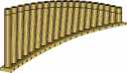  Di 1 Di 2 | Cesar  1 Vocal Mic  1 Di (Charango)  Di 3 | Jaime  1 Vocal Mic (BV/Panpipes) | Ahmed  1 Vocal Mic (Silver  Flute)    1 Conga Mic

STAGE FRONT

YOUR COPY---------YOUR COPY--------YOUR COPY---------YOUR COPY---------YOUR COPY---------YOUR COPY

(Name of sponsor) represented by (sponsor's representative), hereafter known as the sponsor, contracts with the group MarKamusic hereafter known as performer, for a live performance as specified below, and under the following provisions:
Event:
Name of event:___________________________________________________________________hereafter referred to as “performance”.
Description of performance: (indoor concert, festival, nightclub show, private party, etc.) ______________________________________
Address of venue or performance site: _______________________________________________________________________________
Venue’s Phone #s:___________________________ (1),________________________ (2), Venue’s Fax #:_________________________
Representative’s Ph#s:___________________________(W), ___________________________(H), ________________________ ( Cell )
Date of performance (If contract consists of multiple performances, workshops or seminars, please include the whole schedule of performances as part of this contract):_______________________________ Start-time:________________End-time:_____________ Expected arrival time:_____________Access to stage:________________ No. of sets:_______________Length of sets:______________
No. of workshops:____________ Length of workshops:_______________ Theme of Workshops:________________________________

Rain/Snow date: _______________________Notification of cancellation in favor of rain date by:____________________________

Parking: Sponsor will provide close access of performer’s vehicles to the stage for loading and unloading for 20 minutes each time and legal parking for performer's vehicles during performance. If performer is expected to pay for parking, sponsor will be billed accordingly.

Sound System: Sponsor must supply sound amplification system in good working order, conforming to no less than the Minimum Sound System Requirements List detailed on pages 3, 4 and 5 included with this contract.

Courtesy: Sponsor will provide performer with 10 complimentary tickets, refreshments (please include juice, soda and water, ice and 10 cups), a private dressing area and snacks (may include: bread, cookies, cakes, sandwiches, cold cuts, fruits, cheese, etc. No fast foods please. Snacks will not be necessary if sponsor is providing a full meal -please see below).

Meals: If contract requires performer to be more than five hours at performance site (Including Sound System and musical instruments set Up Time), Sponsor will provide one full meal to performers and assistants (no junk or fast foods please).

Acommodations: Sponsor will provide performer with 4 double rooms and 2 full meals/day for a total of ________________ day(s).

Payment- Performance:$__________Travel:$__________Performer’s Sound System:$__________Total payment: $ .00
Please make all checks payable and addressed to:
- 30% deposit _____ weeks before performance date. 70% balance immediately after completion of performance(s)
- ________% of ticket sales (Ticket price: $_______ ) or a guaranteed sum of $______, whichever sum is greater.
- Payment to be made in full immediately before scheduled start time of performance.
Alfredo Chapelliquen, 12 Charles Lane, Amherst, MA. 01002-3801 /

(1)Performer reserves the right to perform a head-count.
(2)Performer reserves the right to sell their recordings and merchandise at the event site and retain all proceeds there from.

(3)Performer must receive sign contract plus 30% deposit ________ days before performance date.
Sponsor: Performer:
______________________________ _____________ Alfredo Chapelliquen ___________
Sponsor’s representative signature Date Performer’s representative signature Date
Please print your name:____________________________ Please print name: Alfredo Chapelliquen
Postal Address: __________________________________ Postal Address: 12 Charles Lane
_________________________________ Amherst, MA 01002
Email:_________________________________________ Email:Markamusic@comcast.net Web Page:______________________________________ Web Page: www.markamuisc.com
Phone #s:__________________(w)_________________(h) Phone #s: 413-549-9155 (w) 413-549-5855 (h)
Fax #:_____________________Cell:__________________ Cell: 413-433-0924

