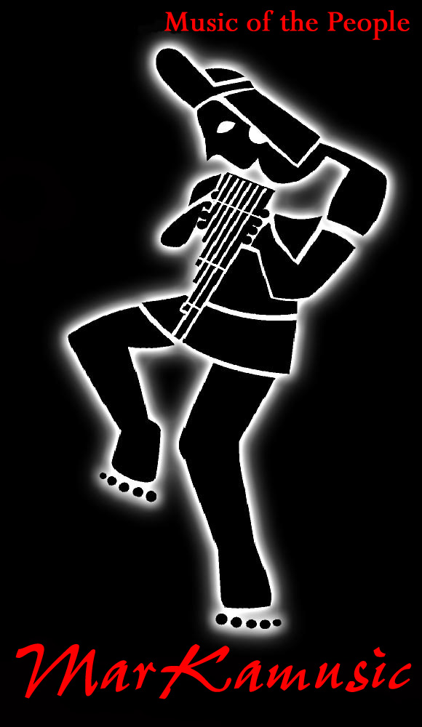
MarKamusic…Music of the People
Notes on an improbable alliance
By Freddy Chapelliquen

In the beginning, the seven-piece ensemble, "MarKamusic" had been performing its unique "Pan-Andean World Beat" music before multi-cultural audiences across the United States. From its conception as an ensemble of South American music, the group expanded its repertoire to include music form other Latin genres, silver flutes, electric instruments and jazz drums complementing the bamboo flutes and diminutive Indian guitars of the folkloric music in marvelous, if sometimes offbeat, ways.

Since then, MarKamusic's musical selections have emerged as a combination of many themes: their own interpretation of ancient Andean aboriginal melodies; songs arising from the twentieth-century Latin American struggle for Political peace; the sometimes jarring, sometimes hypnotic Música Negroide of Peru; of folk-rock protest music—banned in the mid 1970s under pain of death by the military Juntas; and a handful of favorite Caribbean and Latin-American torch songs and high-energy pop tunes. The sum of it all is that chairs are often empty or kicked over at the end of the night: everyone is up on their feet, prancing or kicking about like crazy or taking part in a madcap, coiling conga-line.

Today, MarKamusic—an improbable alliance of three Puerto Rican folk, funk, salsa, Caribbean and Urban-Latin Jazz musicians, a Peruvian popular music multi-instrumentalist and aboriginal-communications scholar, an Uruguayan Funk/rocker and a north American multi-instrumentalist klezmer, world and jazz music has predominantly been following the festival, concert and educational-enrichment-event circuits all over the United States for the last eleven years. They can be seen playing the older music halls and some of the principal big-city international-music clubs in New England.

Currently, the genre of Latin American and more specifically, South American indigenous folk music--with its penchant for native rudimentary instruments which mimic natural sounds and simple, engaging melodies which go straight to the heart--is enjoying a widening audience among North Americans, on both the East and West coasts. Undoubtedly, the heart-beat sound of the "bombo" slack-drum, the steamy-wet-jungle mood set by the "caña de agua" rain-stick, the rain-forest bird and insect noises of the ocarinas, the dreamy hunting melodies of the "quena" (bamboo flute), and the wind-through-the-mountains sound of the "Zampoña" pan-pipes serve as relief from the disconnected, technologically-fabricated sounds of modern commercial music. MarKamusic drew much from this same folk genre, with all its magical foreign sounds, but then took it all to a different place. Since MarKamusic was the result of confronting Puerto Rican musicians with a bunch of South and North American, musicians, the mix could not help but come out somewhat wacky and original. This is musical syncretism in the extreme.

Yet, the transition was smoother than one would expect. For example, MarKamusic member Cesar Calderón, who played drums set in Caribbean, rock and jazz bands for years, had to learn what the Bolivian, Ecuadorian and Peruvian Indians of the Altiplano do on the snare drum (which they, in turn, picked up from Napoleonic military bands in their country during the colonial times). But Cesar's snare-drum rudiments—exercises every drummer has to master when learning how to play—were originally derived from that same old European military tradition anyway. So, he slipped naturally into the Indian snare drumming--which he spices up with tasty Latin and jazz fills. Silver flutist and percussionist Ahmed Gonzalez and bassist Rene Gonzalez, had mastered Puerto Rican Folk and traditional music and Cumbia, Jazz and Salsa, before teaming up with MarKamusic. Ahmed took to the South American indigenous themes and rhythms in a flash. Rene is now playing what essentially amounts to Andean harp lines on his Bass. The ease by which they both slipped into the South American genre given by the fact that their previous musical experiences/genres derived also in part from the same West African rhythms as the South American Afro-Andean sounds. And, gauging from the exhausted, sweaty audiences clamoring for encores at the end of the show, it seems to be working for them quite nicely.

History and background to MarKamusic's music

Text by Freddy Chapelliquen of MarKamusic

The Americas have always been a world of immigrants. The first waves arrived perhaps fifteen to twenty thousand years ago to the northern regions of North America. These very first Native Americans, during the last glaciations era, migrated slowly southward from Asia, across the Bering stretch into North America. Other theorists believe that seamen from as far as the Polynesian Islands may have navigated through the Islands of the Pacific Ocean until they reached the Northern Peruvian coasts. Many myths and legends abound from the civilizations of Mochicas and Chimus that lend support to this theory. There are a good number of visual depictions and cultural artifacts that have been found in archaeological expeditions to the regions inhabited by these two civilizations in northern Peru that illustrate this possibility (such as painted arrival of their Gods from the ocean scenes found in vases and the old rafts of these cultures that resemble many rafts used by the Polynesians). It is very probable though, that our earlier ancestors from Asia were the ones that moved south from Alaska and eventually dispersed into hundreds of bands, clans, tribes, villages and cities first in North America and later in Central and South America. More recent linguistic studies also lend more credibility to this idea. Quechua language has been found to have primarily Semitic roots as well as Arabic influences. It is also thought that at one point, more than 400 different nations coexisted in North America.

At the time of the Spanish and Portuguese invasion of South America and the Caribbean five hundred years ago as many as 1500 indigenous languages were spoken there, matched by at least that many forms of music. Much of this music was vocal, commonly heard in religious and ceremonial rituals. Some cultures had no musical instruments, yet others had literally hundreds, including bull-roarers (a trumpet made from the horn of an animal, elongated empty tree trunks or a conch shell) measuring from a few inches to several feet in length; flutes of gold, silver, cane, human and animal bones; skin drums made from logs, clay or human bodies; wooden gongs fabricated from huge logs. The list is nearly infinite. It is thought that even string instruments existed among some of these cultures, but this theory remains largely debated.

Soldiers of fortune, missionaries and colonists from Spain and Portugal formed the second wave of immigrants to South America, beginning with Columbus' first encounter with the “New” World in 1492. The Iberian musical legacy includes various forms of the ancestor of the guitar which were known then as guitarrillos and other European musical instruments, specially the harp, violin, and military band instruments: trumpet, saxophone and snare-drum. In South America, various regional guitar-like instruments evolved molded by the natives after the small guitar like instruments brought by the European immigrants and colonists of the time. The diminutive Charango (often made from the shell of the Armadillo) and the Ronroco (a larger Charango-like instrument) in the Andes; the twelve-string Tiple in Colombia, the Cuatro in the plains shared by Venezuela and Colombia; and the Viola Caipira and Cavaquinho of Brazil. In Chile Argentina and Peru, the Spanish guitar has remained virtually intact as the most common musical instrument. In the Caribbean as in South America many small string instruments developed too such as the Cuatro, Bordonua and Timple in Puerto Rico and the Tres in Cuba. All over Latin America, Spanish troubadour singing and European influenced strumming traditions, like its stringed instruments and language, persist to this day, in barely modified form.

The third wave—African slaves forced from West Africa—also contributed significantly to the culture, religion and music of the Americas. Hispanic Roman Catholicism allowed African culture and music to continue in ways somewhat reminiscent of the African homeland. Call-and-response singing was allowed to persist, contributing to group-cohesiveness; in the other hand African people found their Indian counterparts to be culturally and musically closer to their own. Music among the Indians was also used to strengthen group cohesiveness, and was practiced communally as an intrinsic part of life itself. So co penetrated was music weaved within the life of the Indians that, in Quechua, the most important language of the Andes, a word to designate the concept of music did not exist. Not only were the social functions of music among Africans and Indians similar, but their dance forms were more reminiscent of each other as well. Both cultures used dance for courtship, to celebrate religious fairs and festivals, ceremonies and social events. The African slaves and the Indians blended their races and their music over the centuries to create a multitude of rhythms inspired by the African and Indigenous mother lands. African slaves juxtaposed their polyrhythms (layers of rhythms in one song) over the indigenous melodies. At the same time new musical instruments such as skin drums made from logs (like the Andean Bombo), musical bows (like the Brazilian Berimbau), stringed instruments (like the Banjo in the U.S.), and xylophones (like the Guatemalan Gourds Marimba) were created in the New World from those that were collectively recalled from West Africa. These new musical forms and instruments can still be discerned today. From the mixture of Indian, African and European bloods new races and sentiments came about. From Indian and European bloods came the Mestizo and from the blend of African and European the Mulatto was born. Nowadays the music, food, clothes, culture and religion from the area reflect these diversely rich heritages. Many aspects of each of these three and subsequent blends survived through the ensuing centuries permeating the fabric of what is identified as Hispanic, Latino or Latino American.

A fourth wave of influence was the modern-day infusion of popular and folkloric culture from the United States. Some of the elements of this cultural invasion came in the form of black music (such as jazz, rock and Funk); electric instruments, and modernized interpretations of North American musical folklore by such artists as Bob Dylan and Joan Baez. The wave of United States black music and youth culture of the sixties inspired the revolutionary troubadours of first Cuba and Puerto Rico, and then Chile and Argentina. This fusion became the Nueva Trova: the anti-authoritarian youth-music movement of the seventies. This new genre found later an audience in South America, giving process to the birth of yet another music form which resembled Nueva Trova. In Chile and Argentina the overthrown democratically elected presidents became an inspiration for a new breed of nationalist musicians. The vindication of all that was native, national and aboriginal was the main goal and thus The New Song Movement saw its birth during the very early seventies as the product of anti imperialistic feelings. In the other hand, the New Song movement in Chile and Argentina simply replicated the process of modernizing and electrifying ethnic folkloric music, as it was done in the United States during the folk boom of the sixties. The New Song was then to become a potent weapon in the struggle against the cruel authoritarian military regimes backed by the U.S. government and its anti-leftist cold war sentiment.

These voices, mixed with the themes, sentiments and rhythms of fading indigenous cultures, evolved into the electric/acoustic “Inca-Rock” of South American bands such as Los Jaivas, Illapu and Charlie Garcia, or the more ensemble oriented such as Inti Illimani and Quilapayun or even the popular city sound bands such as Carlos Vibes who now use these hybrid bicultural artifacts to alert enormous Latin American stadium audiences of the outrages perpetrated against the rain-forest, the plains, the highlands and its inhabitants. Today, many South American tribal groups are extinct, and much of the aboriginal music, like parts of the rain forest, has slowly disappeared. In place of the silenced traditional musical expressions there are many new ones, themselves art forms, attentively responding to the voices of their cultural, social and economic needs, Some are joyful, some are sad or contemplative, but they are always expressive and reminiscent of a glorious, rich past and vibrantly young as the hopes and tears of their present.

The Artists of Marka

FREDDY CHAPELLIQUEN: Guitar, Zampoña, Charango, Venezuelan Cuatro, Bombo and Lead vocals.
Born in Lima, Peru in 1962, he began studying the guitar at the age of twelve. He quickly became familiar with the popular music of Peru, as well as many musical styles of Latin America. Before arriving in the U.S., Freddy toured Guatemala and Honduras with the vanguard Andean group "Maicas”, based in Guatemala City. Freddy pursued graduate work in communications at the University of Massachusetts, Amherst. He focused on the transmission of history and culture in preliterate indigenous societies. Founder and Director of the MarKamusic Ensemble, Freddy also enjoys his work as a producer and recording engineer. Recently, he produced and recorded four albums for Puerto Rican Guitarist and Virtuoso Cuatro player Jose Gonzalez on the Putumayo label, as well as three different albums for MarKamusic and one for Orquesta Komboloko.
AHMED GONZALEZ: Silver Flute, Quena, Congas, Bongos, Latin Percussion and Vocals.
Born in 1981 in San Juan, Puerto Rico, he began studying the Flute at the age of nine, under the famed flutist Sue Kurian. Ahmed began professionally performing the flute, Latin percussion and back-up vocals at the age of fourteen with his father’s band “Banda Criolla”. He currently performs with José Gonzalez/Criollo Clásico and Orquesta Komboloko. Ahmed has recorded nine albums and toured Puerto Rico, Pennsylvania, New England and New York with the bands Criollo Clásico and MarKamusic. and is currently promoting his solo album, Flute Soul. He has also performed alongside: Giovanni Hidalgo, Antonio Caban Vale (El Topo) and famous folk singer Roy Brown.
RENE GONZALEZ: Electric Bass, Timbales, Congas, Bongos, Peruvian Cajon Vocals and Latin Percussion.
Rene Gonzalez has been a multi-percussionist, focusing on Afro-Cuban-Puerto Rican music styles since nine-years of age. Beginning studies on drums with his father at the age of six, Rene studied Rock and Funk. He began an early apprenticeship with noted Puerto Rican percussionist Freddie Moreno on Timbales, Bongos, Tumbadoras, and Latin percussion until the age of 24. He continued these studies with famed percussionist David "La Mole" Ortiz, percussionist Tito De Gracia, percussionist Victor "Papo" Sterling, and others. At the University of Massachusetts' Music Department, Rene studied straight-ahead and big band jazz with acclaimed percussionist Peter Tanner, and Berklee Drumset teacher, John Ramsay. Rene has performed alongside: Giovanni Hidalgo, Antonio Caban Vale (El Topo) folk singer Roy Brown, Cuatro player Eligio "Prodigio" Claudio and bassist Oscar Stagnaro.
SERGIO D’ORSINI: Electric Guitar, Spanish Classical Guitar, Percussion and Vocals.
Born in 1960 in Montevideo Uruguay, he began studying electric Guitar technique at the age of 8. Later he learned to play drum kit as his main instrument until the age of 16 when he began to play professionally. He currently performs with MarKamusic, Orquesta Komboloko and his own group. Although a versatile guitarist of most popular and traditional Latin American styles, Sergio is also acknowledged for his understanding of Latin Jazz, Jazz, Funk, rock and Pop music. He studied at the prestigious Sound Engineering School in Stuttgart, Germany, where he attained a recording engineering degree. After finishing his degree he went to tour all over Europe with his band Poster. Sergio worked with such Uruguayan greats as the brothers Fatoruso, Alfredo Zitarrosa, Los Olimareños and Ruben Rada and is renowned in his native Uruguay for having produced over 60 CDs for Sony Music, Polygram and BMG.
BRIAN BENDER: Trombone, Keyboards, Melodica, percussion and Vocals.
Brian has a diverse musical background that includes Latin Jazz, Salsa, Merengue, World Beat, Klezmer, Jazz, Dixieland, Reggae, Samba, Calypso, Funk, Afrobeat, Celtic and other musical styles. He has performed in Egypt, Alaska, Israel, West Africa, Italy, France, Spain, Germany, Holland, the United Kingdom and throughout the United States. Brian has performed at Carnegie Hall, the Presidential Inauguration of Bill Clinton, the Knitting Factory (NYC) and many other festival and concert venues. Some of the groups that Brian has performed with: The Pangeans (World Beat), Black Rebels (African Reggae), The Wholesale Klezmer Band, Big Bandemonium (Celtic music), The Gumbo Jumbo Dixieland Band, Little Shop of Horas (Jewish-World Fusion) and The World Beatniks (World Beat)
IDOEL ORTIZ: Bass Guitar.
Idoel was Born in Puerto Rico, He began studying music from an early age and quickly took a liking to Hip Hop, Urban Jazz and Latin music. The bass became his instrument of choice. Idoel family moved from his native Puerto Rico to the United Sates when he was still very young. They decided to settle in Western Massachusetts, where he finished his schooling. Back in 1999 Idoel founded His own ensemble HPB with his friend Cesar Calderon. In recent years Idoel resides in western Mass and remains with his own group’s musical director.
CESAR CALDERON: Drum set and Latin Percussion.
Born in 1986 in San Juan, Puerto Rico, he began studying snare drum technique at the age of 6. Cesar began to play professionally, at the age of 16 (at the time performing on percussion). He currently performs with MarKamusic, HPB and the Sergio D’Orsini Group. Although a versatile drummer of most popular and traditional styles, Cesar is acknowledged for his understanding of Hip Hop, Urban Jazz and Afro-Caribbean drum set playing. Cesar has recorded 7 albums with various groups and two with MarKamusic.

