Community Event Concert
A concert by Latino American Ensemble MarKamusic



MarKamusic…
the music and the mystery
of the Americas in a breath
of modern and ancient sounds

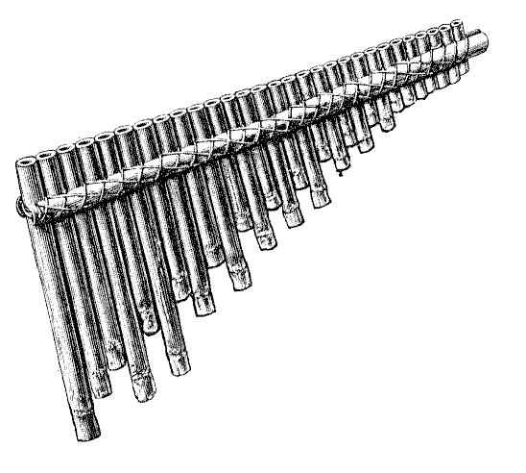



www.markamusic.com

