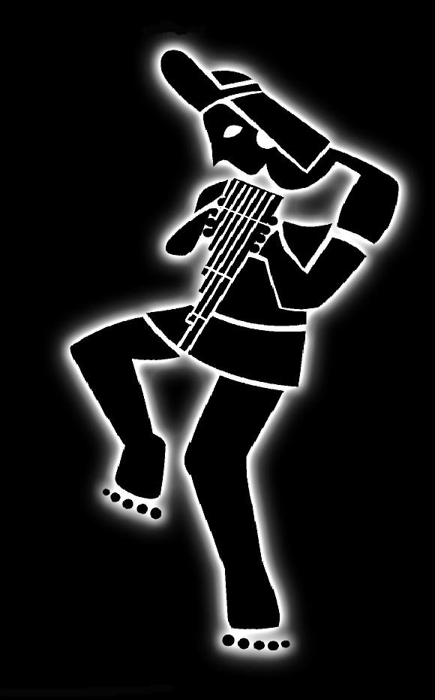

Educational
Offerings

Workshops

Lectures

Seminars
Residencies
Instrument Making

Educational presentations

Descriptions

Contents

Historical Background

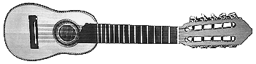

www.markamusic.com

Educational Talks – Workshops – Seminars - Lectures - Residencies

Since 1999, the ensemble MarKamusic has given many successful workshops, residencies and educational presentations at Pre–K schools, grade schools, middle schools, high schools, senior centers, colleges, universities, museums and other educational institutions and groups. These events are designed to broaden people’s cultural horizons and awareness of Latin American culture, music and history by drawing upon the considerable communication skills of the group’s members. Among our members there are four composers, three instrument-makers, three teachers, two lecturers, and a scholar in the transmission of culture through oral and musical means in aboriginal societies. An extensive educational resource guide, prepared by MarKamusic member Freddy Chapelliquen, is available upon request to schools in advance of an educational presentation. These presentations can be tailored closely to the age, educational level and time requirements of your audience. The workshops can range from half an hour to several hours, days or weeks in length.

The themes of the educational presentations offered are summarized as follows:

Sounds of the Americas
The earliest expressions of musical culture on the Americas were recreations of the natural sounds found in the aboriginal environment. Resourcefulness was the key and the original inhabitants recreated the only music known to them: the sounds of their native surroundings. The native people mimicked the sounds of wind, rain, falling water, rushing water, lightening, thunder, heart beat, snakes, insects and a multitude of birds with the simplest of artifacts and found objects including: reeds, seeds, dried gourds, seashells, conches, pebbles, stones, animal and human bones, logs, and animal skin. Before the European invasion (especially in South America), many styles of music had emerged during the previous centuries as civilizations developed, matured and fell. Successive migrations - some cruel and devastating, some unwilling, and some welcome, each left their own unique, indelible stamp on the music and culture of the Americas.

- Sounds of South America
Given the absence of handwriting, music and song emerged as the principal vehicle for passing on history, traditions and values from one generation to the next. For instance, the oral medium during Inca times was comprised of poetry, theater, oral tradition and most importantly music. The Amautas or wise men, recited short stories generation after generation to instruct the children as well as to remind elders of their traditions. Important events were turned into verse by the poets and Haravecs (Inventors) in order to be sung at festivals or after war victories. The historic process of struggle and transformation during the ensuing centuries also left its unmistakable trace on the content and context of the music. The result is that South American music is today a complex blend of native-indigenous, Euro-Iberian, West African—and most recently—North American influences. These voices mix with the lyrics, themes, sentiments and rhythms of fading indigenous cultures. Nowadays, many South American tribal groups are extinct, and much of the aboriginal music, like parts of the rain forest, has disappeared. In place of the silenced traditional musical expressions are new ones, themselves passionate art forms - some joyful, some sad, but always expressive.

Sounds of the Caribbean
The indigenous peoples of the Caribbean Islands were the Carib, Taino, Arawak and Ciboney. They inhabited theses islands for hundreds of years before the invasion of the European empires. It was actually the Carib Indians who lent their name to the Islands. Christopher Columbus was the first European to land in the Islands which led to Spain claiming the entire region. The European powers of that time including England, France, Portugal, the Netherlands and Denmark responded by waging war with Spain and each other, eventually claiming Islands of their own. As a result, the native aboriginal peoples were nearly annihilated, and their way of life almost rendered extinct. The imperial powers instituted slavery on the islands, causing the native cultures to slowly be replaced by those carried over from Africa who were already colonized by the Europeans. Out of this mixing of cultures many new cultures were born and in time their music reflected these dynamic changes. Unique rhythms were cultivated on every island, from Reggae through Merengue, Bachata, Son, Calypso, Compas, Zouk and Soca to Salsa (in its different versions either from Cuba or Puerto Rico). Often joyous and danceable, Caribbean music also serves to contest inequity, protest imperialism and injustice, and offer social commentary particularly in Nueva Trova, Calypso and Reggae. Many musical instruments are inherited from the aboriginal people such as the Guiro, Maracas and other rattles and the Claves. Yet others are the result of the ingenuity of the African slaves who resorted to using the materials their tormentors discarded. Today, this can still be seen in Steel drums made out of empty barrels of oil, the Tambora Dominicana made out of an empty barrel of wine or rum, and the Cuban Cajon originally made out of an empty fruit box.

The Educational presentation formats are summarized as follows:

Performance with or without Extended Commentary
MarKamusic offers a performance with extended introductions and commentaries prefacing each number. Various theories on how ancient native and traditional instruments may have come about are revealed along with detailed descriptions of many of the instruments to be used during the performance. The provenance and the socio-cultural contexts from which each song emerged and their lyrical content are explained. Finally, the historical and geographical background of the song is revealed as well. A few members of the audience are welcomed onto the stage to perform a couple of songs with the band by playing simple musical patterns on percussion instruments. Toward the end of the performance, questions are welcomed from the audience with the encouragements of the group. These introductory discussions can be varied in length, content and audience participation-interaction according to the presenter's needs.

Interactive Concerts with or without Discussions
MarKamusic members present a lively series of interactive discussions about traditional, native/aboriginal and western instruments used in Latin America, historical notes about the cultural and socio-economic contexts that produced them, the many different forms of South American music, and how they have evolved from the early musical expressions of the original native population into the modern mix of multi-national traditions. The varied instruments are placed on display and participants are encouraged to handle them. Given the time, small groups of volunteers are shown how to play basic rhythmical patterns on the percussion instruments. The workshop is concluded with a question and answer discussion period.

- Spanish class
These workshops are primarily designed as a cultural experience for a Spanish class, preferably for an advanced group yet, the ensemble will tailor it to any level audience. These presentations are a vehicle to expose members of the audience to the culture of Latin America and its language in an authentic, experiential context. MarKamusic conducts the workshop as much as possible in Spanish (this will be done according to the Spanish competency level of the audience). The exchange will center on the instruments and the music performed by the ensemble, with comments about the contextual provenance of songs, instruments and rhythms, lyrical content and the specific cultural groups that produce them. This is a very interesting approach since there are more than 25 countries in Latin America with distinctively different musics and cultural traditions. We aim to debunk western dominant culture’s stereotypical view of Latin America as a singular, non-distinct culture. Even though the repertoire of the ensemble does not include all the "musics'' or instruments that can be found in Latin America our selection is a good first approximation into the music and culture of the continent. Finally we may share the personal cultural experiences of the Latino band members. This type of workshop provides a well-rounded and entertaining cultural event for young people of all ages.

- Academic Workshops, Seminars, lectures and Demonstrations
In these lectures/workshops MarKamusic expands on the historical socio-political development of Latin America through its musical traditions. The music of the region replicated the ongoing ideological and economic changes that took place in the continent after the European invasion. The social functions of music also changed over the centuries and played an indispensable roll within Latin American societies. Right after the conquest, as the authoritarian Spanish rulers seized control of all official ideological apparatuses (government, school, church and family nucleus), music became the only available vehicle of expression for the fading aboriginal groups. Later in the 1900’s during the era of the military dictatorships and caudillos – 60’to the 80’- popular music became the single most effective political channel for newly developed vanguard political organizations. In order to understand how music acquired its political voice, it is necessary to address the historical context that gave it birth. To begin with, most of the native civilizations lacked hand writing, therefore music had already acquired the greatest importance as a communication vehicle prior to the European invasion. Throughout the last 500 hundred years, music was the space where the Indians, the dispossessed and the bethroden entrusted hopes, disappointments and successes. It was not until the early 70’s when the political edge of music reached its most important phase, particularly with the coup d’etat that removed democratically elected president Allende in Chile. The Pinochet military Junta outlawed all performance and airings of Andean music and its instruments of choice because Andean musicians had politically favored and helped to propagate the tenets of Allende’s ideology through the content of their songs. In Chile, Andean music and musicians became synonymous with “communist”. The political processes in other South American countries gave birth to new hybrid types of musics that mixed Rock, Classical Music and Jazz with Traditional music. The western elements present in these new hybrid musical forms made the music acceptable to the regimes that had decried traditional music forms as socialist and thereby, prohibited. At the same time, the social movements of the era gave start to a massive process of creolization, which will also be revisited to explain how it aided in the creation and propagation of new and emerging musical traditions. The influx of western cultural discourses, the role of tradition and folklore in the dissemination of popular culture and music, the politicization of musical texts and the phenomenon of cultural imperialism in postmodern Latin America will all be discussed in order to contextually understand the music produced in Latin America from a social constructivist approach (ideologization into liberation). This would be a workshop/lecture of high academic interest for a Sociology, Anthropology, Latin American Studies, Political Science or Ethnomusicology class/department.

Hands-on Workshops

Instrument Making Workshops (Good For Audiences Ages 5 and Up)
These workshops focus on traditional wind and string instruments. After a presentation on the traditional instruments and their origins, suitable materials and simple tools (provided by sponsor) are distributed to the participants (lengths of PVC pipe, glue, corks, duck tape, small tin cans, grains, pebbles, sections of wood dowels, keys, fishing lines, etc) and they are then instructed and supported in the making of zampoñas (Andean pan-pipes), wind makers, whistles, bird callers, or shakers. The participants are then shown the rudiments of panpipe, shaker, whistles or bird caller playing. Contingent upon available time, participants are shown one or more simple traditional patterns. Time permitting these hands-on instrument making workshops can be combined to include all five instruments or as many as you would like. The Pan Pipe making workshop is the lengthiest of all and it requires at least four solid hours for completion. Residencies on stringed instrument making, the history of the Puerto Rican Cuatro, the evolution of Puerto Rican String Instruments and the history of the Spanish guitar are offered by MarKamusic friend, guitar maker and educator William R. Cumpiano by special arrangement.
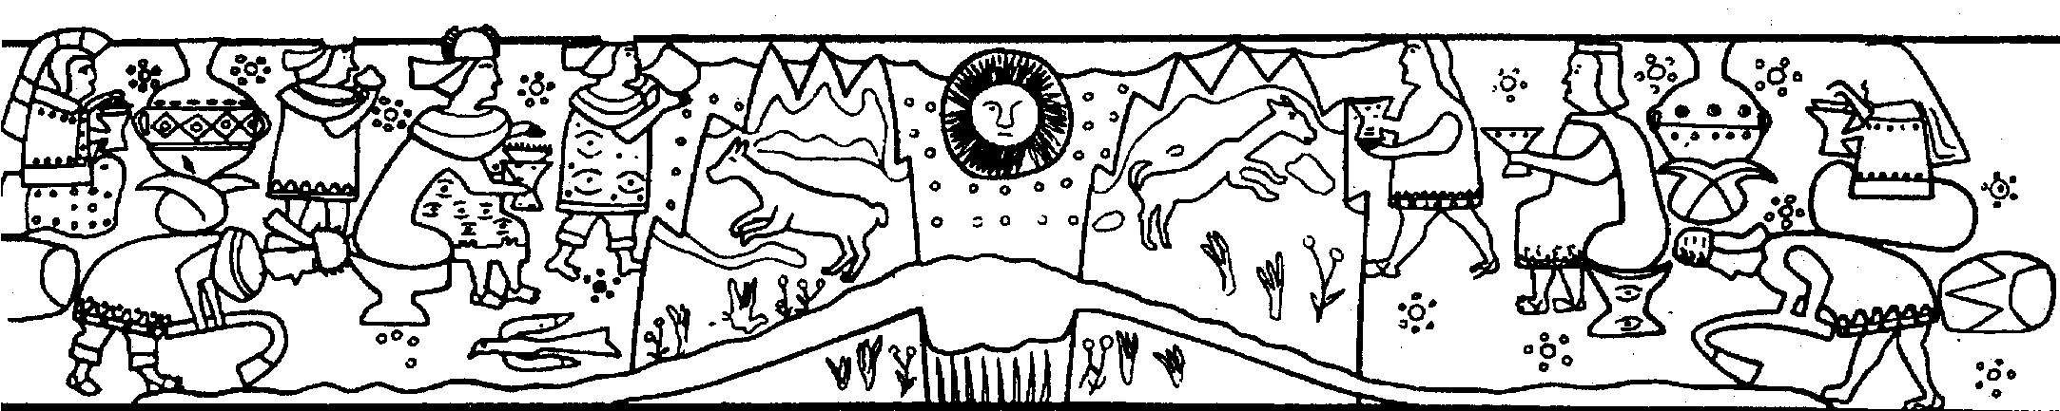

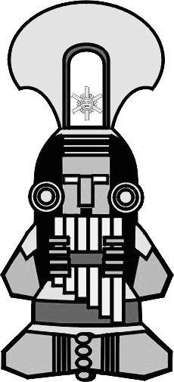

The sounds of South America

Teachers’ Guide

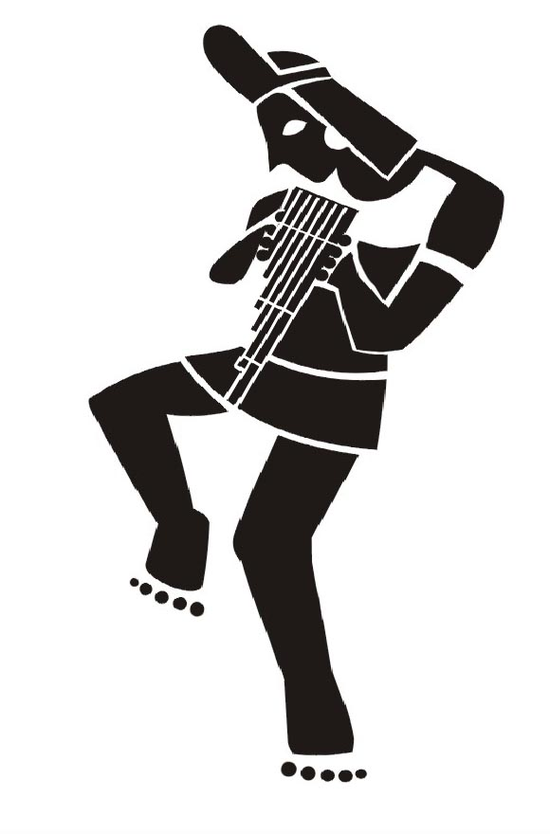
Music of the people 12 Charles Lane, Amherst, MA 01002-3801. Phone: 413-549-9155, Email: Freddy@markamusic.com

About MarKamusic:
From the windy barren high plateaus of the Andes, the mystical Amazon and Caribbean rain forests, the desert coasts washed by the Pacific and the Atlantic and the heat of the Caribbean comes a high-energy, multi-national musical ensemble that performs music deeply rooted within the folkloric, pop and traditional genres of Latin and South America. MarKamusic musicians sensibly render the musical forms and the soulful art of the cultures and countries from the south. The resulting product is an ever changing, eclectic weave of ancient, modern, aboriginal and popular themes performed on a fascinating array of native-indigenous, western and African influenced instruments. Like their ancestors before them, MarKamusic musicians draw from the depths of their unique cultural past: Inca, Quechua, Maya, Aymara, Taino, West African and Iberian. MarKamusic embraces musical history but then takes it to an altogether different place. Fused with the feelings and creations of younger generations, during its performances and workshops, MarKamusic emphasizes the musical and cultural contributions of the four major influences that have shaped modern Latin American music at large: the indigenous, the West African, the Iberian, and the United States. Traditional rhythms and musical forms from these diverse cultures slowly fused over the centuries, creating today's South American and Latin American traditional, folk and popular musics. MarKamusic's careful choice of repertoire and instrumentation conveys this historic evolution to the audience. Deeply moving and full of fresh and ancient energy, MarKamusic’s songs call out to the senses of our collective human memory and to the doors of our ancient hearts. A sense of unity is evoked among listeners as they share the enchanting musical journey of MarKamusic.

MarKamusic’s Goals:
MarKamusic’s goal is to debunk western stereotypes of South American music and culture in particular, and Latin music and culture at large. By sharing the many musical gifts of these lands in their purest forms as well as blended with newer, hybrid creations of subsequent artistic and historic musical developments, MarKamusic portrays the vast cultural wealth of these regions in a cornucopia of musical knowledge. In the United States, profit interested groups have purposely created an aura of mysticism and mystery around the South American music genre and its people. Their efforts, geared to maximize the genre’s consumption and thus their own profitability, have misinformed North American audiences about the poise, representation, performance, accuracy and content of South American music. In combination with North American’s increasing interest in cultural diversity, North American audiences have been deceived into accepting profit-motivated, prepackaged products. MarKamusic treats these exquisite musical traditions with the care and love fostered by our own ancestral roots and hopes to share with listeners the enriching recognition that America is larger than the United States; that America in fact stretches from the state of Alaska down through the tip of Tierra del Fuego. The members of MarKamusic feel that our multiplicity of cultures tied by history and geography but separated by politics, race and language can most effectively be reconciled by the sharing, indeed, the merging, of our musical-artistic expressions. MarKamusic musicians strive to embody the potential for this harmonious exchange by drawing on the talents and resources of one Peruvians, one Ecuadorian, three Puerto Ricans and one Guatemalan.

Historical Background to MarKamusic's music

The Americas have always been a world of immigrants. The first waves arrived in the Northern regions of North America fifteen to twenty thousand years ago. These very first Native Americans, during the last Ice era, migrated slowly southward from Asia, across the Bering stretch into North America. Other theorists believe that seamen from as far away as the Polynesian Islands may have navigated through the Islands of the Pacific Ocean until they reached the Northern Peruvian coast. Many myths and legends abound from the Mochica and Chimu civilizations that lend support to this theory. There are a good number of visual depictions and cultural artifacts that have been found in archaeological expeditions to the regions inhabited by these two civilizations in northern Peru that illustrate this possibility (such as scenes depicting the arrival of their Gods from the ocean found on vases and the rafts of these cultures that resemble many rafts used by the Polynesians). It is very probable though, that our earlier ancestors from Asia were the ones that moved south from Alaska and eventually dispersed into hundreds of bands, clans, tribes, villages and cities first in North America and later in Central and South America. More recent linguistic studies also lend more credibility to this idea. The Quechua language has been found to have primarily Semitic roots as well as Arabic influences. It is also thought that at one point, more than 400 different nations coexisted in North America.

At the time of the Spanish and Portuguese invasion of South America and the Caribbean five hundred years ago as many as 1500 indigenous languages were spoken there, matched by at least that many forms of music. Much of this music was vocal, commonly heard in religious and ceremonial rituals. Some cultures had no musical instruments, yet others had literally hundreds, including bull-roarers (a trumpet made from the horn of an animal, elongated empty tree trunks or a conch shell) measuring from a few inches to several feet in length; flutes of gold, silver, cane, human and animal bones; skin drums made from logs, clay or human bodies; wooden gongs fabricated from huge logs. The list is nearly infinite. It is thought that even string instruments existed among some of these cultures, but this theory remains largely debated.

Soldiers of fortune, missionaries and colonists from Spain and Portugal formed the second wave of immigrants to South America, beginning with Columbus' first encounter with the “New” World in 1492. The Iberian musical legacy includes various forms of the ancestor of the guitar which were known then as guitarrillos and other European musical instruments, especially the harp, violin, and military band instruments including the trumpet, saxophone and snare-drum. In South America, various regional guitar-like instruments evolved that the natives molded after the small guitar like instruments brought by the European immigrants and colonists of the time. The diminutive Charango (often made from the shell of the Armadillo) and the Ronroco (a larger Charango-like instrument) in the Andes; the twelve-string Tiple in Colombia, the Cuatro in the plains shared by Venezuela and Colombia; and the Viola Caipira and Cavaquinho of Brazil. In Chile and Argentina, the Spanish guitar has remained virtually intact as the most common musical instrument. In the Caribbean as in South America, many small stringed instruments also developed including the Cuatro, Bordonua and Timple in Puerto Rico and the Tres in Cuba. All over Latin America, Spanish troubadour singing and European influenced strumming traditions, like the stringed instruments and language, persist in barely modified form to this day.

The third wave—African slaves forced from West Africa—also contributed significantly to the culture, religion and music of the Americas. Hispanic Roman Catholicism allowed African culture and music to continue in ways somewhat reminiscent of the African homeland. The continuance of call-and-response singing permitted group-cohesiveness to persist. African people found their Indian counterparts to be culturally and musically closer to their own. Music among the Indians was also used to strengthen group cohesiveness, and was practiced communally as an intrinsic part of life. So immersed was music within the life of the Indians that, in Quechua, the most important language of the Andes, a word to designate the concept of music did not exist. Not only were the social functions of music among Africans and Indians similar, but their dance forms were more reminiscent of each other as well. Both cultures used dance for courtship, to celebrate religious fairs and festivals, ceremonies and social events. The African slaves and the Indians blended their races and their music over the centuries to create a multitude of rhythms inspired by the African and Indigenous mother lands. African slaves juxtaposed their polyrhythms (layers of rhythms in one song) over the indigenous melodies. At the same time new musical instruments such as skin drums made from logs (like the Andean Bombo), musical bows (like the Brazilian Berimbau), stringed instruments (like the Banjo in the U.S.), and xylophones (like the Guatemalan Gourds Marimba) were created in the New World from those that were collectively recalled from West Africa. These new musical forms and instruments can still be discerned today. From the mixture of Indian, African and European bloods new races and sentiments came about. From Indian and European bloods came the Mestizo and from the blend of African and European, the Mulatto was born. Nowadays the music, food, clothes, culture and religion from the area reflect these diversely rich heritages. Many aspects of each of these three and subsequent ethnic/racial blends survived through the ensuing centuries permeating the fabric of what is identified as Hispanic, Latino or Latino American.

A fourth wave of influence was the modern-day infusion of popular and folkloric culture from the United States. Some of the elements of this cultural invasion came in the form of black music (such as Jazz, Rock and Funk); electric instruments, and modernized interpretations of North American musical folklore by such artists as Bob Dylan and Joan Baez. The wave of United States black music and youth culture of the sixties first inspired the revolutionary troubadours of first Cuba and Puerto Rico, and then Chile and Argentina. This fusion became the Nueva Trova: the anti-authoritarian youth-music movement of the seventies. This new genre later found an audience in South America, giving process to the birth of yet another music form, which resembled Nueva Trova. In Chile and Argentina, the overthrown democratically elected presidents became an inspiration for a new breed of nationalist musicians. The vindication of all that was native, national and aboriginal was the main goal and thus The New Song Movement saw its birth during the very early seventies as the product of anti imperialistic feelings. On the other hand, the New Song movement in Chile and Argentina simply replicated the process of modernizing and electrifying ethnic folkloric music, as it was done in the United States during the folk boom of the sixties. New Song was then to become a potent weapon in the struggle against the cruel authoritarian military regimes backed by the U.S. government and its anti-leftist cold war sentiment.

These voices, mixed with the themes, emotions and rhythms of fading indigenous cultures, have evolved into the electric/acoustic “Inca-Rock” of South American bands such as Los Jaivas, Illapu and Charlie Garcia, or the more ensemble oriented such as Inti Illimani and Quilapayun or even the popular city sound bands such as Carlos Vives who now use these hybrid bicultural artifacts to alert enormous Latin American stadium audiences of the outrages perpetrated against the rain-forest, the plains, the highlands and their inhabitants.
Today, many South American tribal groups are extinct, and much of the aboriginal music, like parts of the rain forest, has slowly disappeared. In place of the silenced traditional musical expressions there are many new ones, themselves beautiful art forms, attentively responding to the voices of their cultural, social and economic circumstances - some are joyful, some are sad or contemplative but they are always expressive and reminiscent of a glorious, rich past while remaining as vibrantly young as the hopes and tears of their present.

The Performances
In South America, the most common forms of Indigenous, folkloric, traditional, Hispanic and/or African-derived music and dance usually occur as nationalistic expressions of particular countries. MarKamusic performs many of these musics. Among which are:

"Moliendo Café" a song about love …………..…………………a CUMBIA from Colombia
"Montilla" the first black revolutionary of South America………a JOROPO from Venezuela
"Candombe Mulato" extols pride in the mulatto race….…......a CANDOMBE from Uruguay
"Ñucallacta" celebrates the homeland………………………a SAN JUANITO from Ecuador
"Sariri" a song for a homesick boy……………………………..…..…a TINKU from Bolivia
"Bossa" a rhythm influenced by African music………………….…a Bossanova from Brazil

The Instruments
MarKamusic's musicians are called upon to play over forty familiar and exotic instruments to create the unique musical textures, tonalities and colors of the many lands and cultures in the South American continent. These instruments are the product of native aboriginal musical craft traditions, which have evolved over millennia, as well as from African, European, and North American sources, which fused with the indigenous instruments to create hybrid versions of the above. Some of the less familiar instruments that you may see and hear over a MarKamusic performance can be classified in three main groups:
Wind instruments, percussion instruments and string instruments.

Wind Instruments

Quena: [Kéh-nah] A foot-long bamboo flute with a simple notched mouthpiece and seven holes, six on top and one under which produces a hunting, sweet and melancholic sound. The oldest quenas found in Peru predate the Inca times as much as 3500 hundred years. Originally, this instrument was made out of the leg bones of flamingos, human femurs and bamboo. Today is mostly built out of bamboo or wood and there are variations made out of PVC pipe and copper pipe. During the times of the Spanish colony, the Spanish prohibited the Indians from playing it because they thought the Indians became estranged by its sound as well as provoking rebellious feelings among them. Its beautiful and distinctive tone can be heard today throughout the Andean regions of South America and it is probably the wind instrument of choice among the indigenous people, especially herders and peasants. A longer, deeper toned variant is called the Quenacho, and another variant with an extended mouthpiece is called the Pinkuyo.

Peruvian Quena

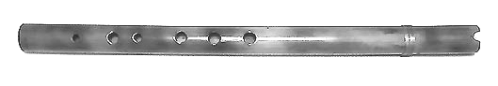

Zampoña: [Sahm-póhn-yah] A generic term for a family of wind instruments each consisting of a collection of thin bamboo tubes strapped together in a form similar to East-European Pan-pipes. The Zampoña family ranges in sizes from the tiny Chuli to the six-foot long Toyos. The Zampoña is the oldest of the South American indigenous flutes. It is believed that as early as 5000 years ago this instrument was used in its pentatonic version. It was not until the arrival of the Europeans that the Zampoñas acquired their tuning in G. Some ethnomusicologists believe that the name of this family of instruments stems from a mispronunciation by the Indians of the word symphony (sinfonía in Spanish). Other members of the family, of different sizes and tuning arrangements are called Maltas, Bastos, Semitoyos, Sikus, Antaras, Rondadores and Payas (from Ecuador). The names always varying according to their regions of provenance. In the Andean mountains, you can often see pairs of Zampoñeros playing alternate notes in rapid succession resulting in a kind of "stereo" effect. Traditionally, two individuals divide the Zampoñas into two separate rows of pipes so that while one of the players is “breathing” the other player is playing and vice versa. A great degree of synchronization is required of the players to successfully accomplish this activity.
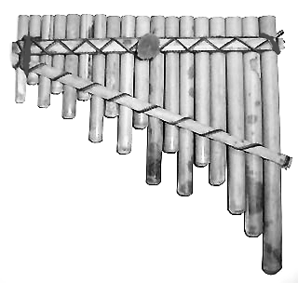
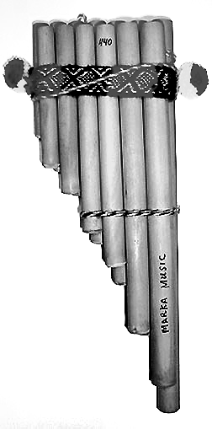
The Indians probably devised the instrument this way because since they live in the high plateaus of the Andes over 12,000 feet of altitude and the air is so thin there, they could rapidly hyperventilate by playing the instrument, and also because every aspect of their existence is defined by a communal attitude toward life.

Peruvian Zampoña Ecuadorian Rondador

Ocarina: A ceramic flute which appears in many fanciful shapes, from that of birds, reptiles, fish, and turtles to unrecognizable lumpy shapes. Other varieties of these instruments have recently been fabricated out of wood and even plastic. It is played all over North, Central and South America. It usually has from four to six holes and is played by covering the holes with the fingers of both hands in an alternating fashion. The ocarina is used primarily to recreate haunting melodies as well as various pitches of bird and insect sounds.
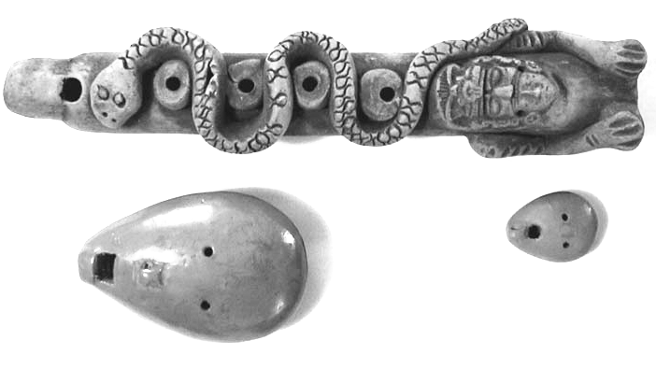

Mayan Ocarina→

Peruvian Ocarinas →

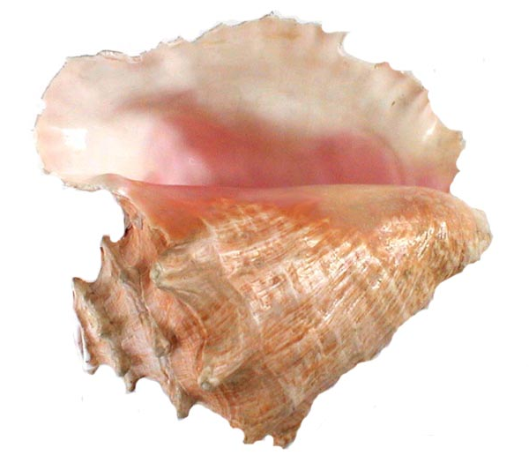
Concha: [Kohn-chah] Known as the Pututo among the Indians of the highlands in South America, is the familiar Conch shell. The Instrument is used to this day in South and Central America to produce loud trumpeting sounds, often to announce the commencement of communal gatherings, religious fairs, festivals and processions. In order to build this instrument the Indians locate a 50 to 70 year old conch. They cut the top head or axel, leaving an opening at the top of the conch through which they will blow in a manner very much like a regular trumpet. The pitch of the conch is changed by introducing and alternating the depth of the hand in the sound hole.

Peruvian Conch Pututo

Tarka: Is an ancient Andean wind instrument made out of wood, which has a rectangular shape if viewed transversally. Its length varies between 14’’ and 20’’ and its diameter between 2’’ and 3’’. It has a mouthpiece and six holes on the top. The Tarka can produce a full octave and a half, which allows it to create rich and complex melodies. However, in the folklore of the Andean regions, it is typically used to produce simple and repetitive melodies. The provenance and age of this instrument are undetermined. Though the Tarka probably had European influence, it is definitely pre-Hispanic. This instrument produces a haunting sound and it was mostly used for religious ceremonies and dances.

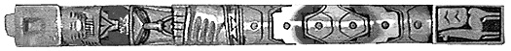

Bolivian Tarka
String Instruments
Charango: [Chah-rahn-goh] Diminutive high-pitched ten-string instrument played throughout the Andean region, the product of indigenous artisans inspired by the Spanish Guitar and Vihuela. The face and neck look like a miniature toy guitar, and the soundbox consists of carved wooden shell or the dried skin of lizards or armadillos. It is most often played by rapidly fanning or plucking the strings. A larger variant is called the Ronroco.
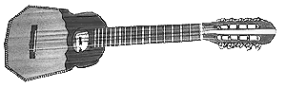
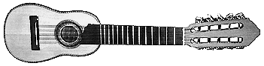

Bolivian Charango Bolivian Ronroco

Tiple: [Teeh-pleh] A small, guitar-like string instrument, most often seen in Colombia. It is strung with four sets, or courses of three strings each, and has a distinctive nasal, high-pitched sizzling sound, much like a twelve steel string guitar. In later years, the tiple has gained recognition primarily through experimental musicians (Sting) and Jazz players (such as Pat Matheny) with an ever-changing hunger for exotic sounds.

Cuatro: [Kuah-troh] A tiny Venezuelan/ Colombian string instrument played by the people of the plains shared by the two countries. In recent years, it has spread over much of South America. Similar to the Hawaiian ukulele, the cuatro has four strings and is strummed rapidly to produce a lively, percussive, bouncy sound.

Percussion Instruments
Cajón Peruano: [Kah-hón- Peh-ru-ah-noh or peruvian Cajón] A percussion instrument originating from the black folkloric tradition of Peru, it consists of a wooden box played by rhythmically slapping its thin front surface at various angles and heights while the player sits on its top. The front face is only partially fixed to the body of the box, giving a distinctive rattling sound when played. Often, loose piano strings or broken reeds are attached to the rear surface of the front face, which vibrates against them producing a sound very similar to a snare drum. The back face of the Cajón is a fixed plate of wood with a circular sound hole right in the middle. The Peruvian Cajón can produce a great variety of sounds and timbres in very many different pitches which make it rival a whole drum kit. It makes sense that an instrument like this one would develop among the African slaves in coastal Peru. The dispossessed slaves would also use their cajones as a chair, as a table and as a box where they could transport and keep their few belongings. In recent years the Peruvian Cajón has become quite popular among world beat and Jazz musicians, who use it for its ease of handling and transportation while traveling to rehearsals. Its small size makes it more manageable than whole drum kit.

Caña de Agua: [Kán-ya deh áh-guah] Known in English as the Rain Stick, it is a sound-effect device that mimics the sound of rushing water or drizzling rain depending on how you handle it. It originated in the Pacific coast of South America, specifically in the northern desert coasts of Chile, where it was made from a length of sun-dried cactus-branch. The cactus thorns were pulled out and then reinserted point-end first, while the cactus branch was still green. After the cactus dried out, one end was sealed and the cactus was then filled with seashell fragments, very small pebbles or hard seeds. The open end was then also sealed shut. The Rain Stick spread as far as Mexico, where it was made from lengths of bamboo. In the desert regions of its provenance, it was originally used in religious ceremonies held to end the drought and call in the rains.

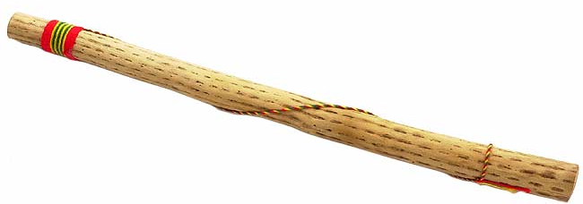
Rain Stick

Güiro: [Gwee-roh] A bottle-gourd instrument of African origin made from a long, hollow gourd. On its surface, it has indentations that are stroked by a flexible wooden stick or fork-like scraper to make a rhythmic, scratching noise. The Güiro is played all over Latin America, but it is used mostly in Afro-Caribbean music.
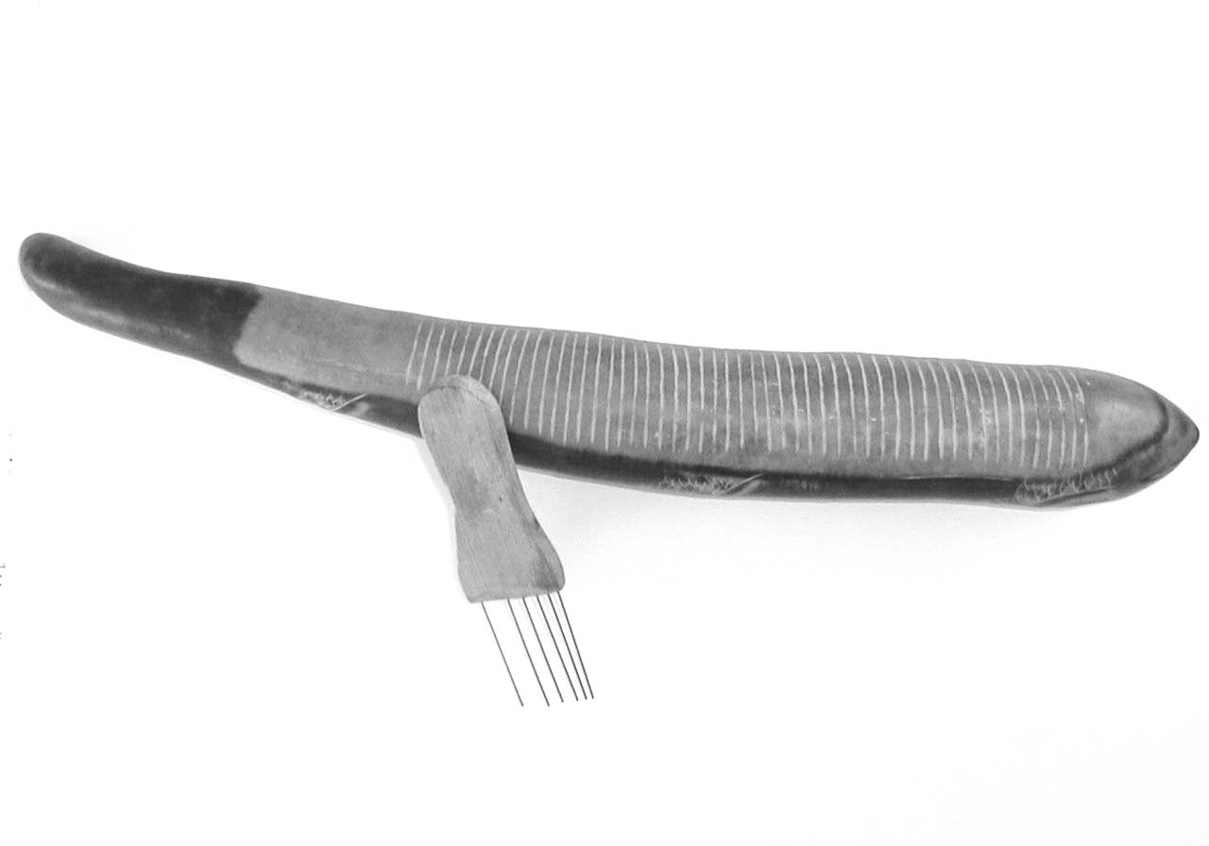
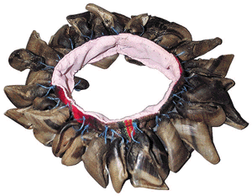

Peruvian Güiro Bolivian Chajchas

Chajchas: [Chah-chahs] A uniquely Andean percussion instrument known also as Chullus, it consists of a woven ribbon with numerous dried goat-hooves tied onto it. When it is shaken, it suggests the sound of wind and falling rain. Chajchas can also be found made with seashells, stones, beads, seeds or scraps of hardwood.

Ganza: In its most rudimentary form, this Brazilian noisemaker consists of a tin can partially filled with sand or fine pebbles, which is shaken rhythmically to produce percussive patterns.

Bombo Legüero: originating in Bolivia and Argentina, this large two-headed slack bass drum consists of a hollow tree trunk with cowhide on both ends. A common arrangement is to have one head made from cowhide and the opposite head made from sheepskin with the wool intact. It is played with either sticks or a muffled beater. Bombos change name and size and vary in appearance from country to country. In Peru is also known as Wancara. Later versions of these instruments are made out of a thin sheet of steam-bent/curved plywood yet others are made out of wood cut into a cylindrical shell. It takes its name from the distinctively deep, muffled sound that it produces and from the onomatopoeia of its sound (bom-bom-bom = bombo). This instrument derives of West African influence since there were no drums with hides tied on top until after the forced arrival of the African slaves to South America.
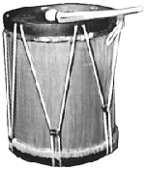
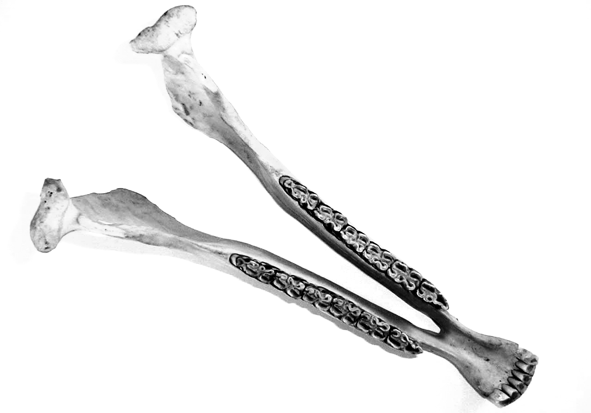

Argentinean Quijada de Burro
Bombo Legüero (Peruvian Donkey Jaw)

Quijada de Burro: Better known as Quijada or Donkey Jaw, it literally originated from a lower donkey Jaw which teeth have remained attached after it dried out and devoided of all flesh, by gluing and securing the first molar, which does not permit the other teeth to fall out, it rattles when hit rhythmically creating a very distinctive percussive sound. It is widely used in the Afro-Peruvian musical tradition and in Brazilian Music.

Tortuga: Tortuga in English literally means turtle. The Tortuga is exactly a hollow and dried turtle shell that is turned upside down and then hit with a mallet on both open ends to produce a percussion sound very similar to the modern wood blocks. In fact, this instrument is the predecessor of the wooden blocks. The Tortuga is a Mayan instrument native to Guatemala but can also be heard in southern Mexico, Central America and as far South as the Amazon Jungle.

Other instruments played by MarKamusic: STRINGS- classical guitar, electric bass, twelve string steel guitar; WIND- silver flute, sax, Yapurutu, wind makers, bird callers; PERCUSSION- congas, claves, maracas, bongos, kit drum, tambourine, Peruvian shaman rattles, stone chimes, bamboo chimes, key chimes, cowbell, croak maker and sea shell chimes.

Things to do with your students:

- Using a world map, identify (or review) all of the continents. Note "The Americas" which comprise North America, Central America and South America. Point out the location of the Caribbean region, comprised of the islands of the Greater Antilles and Lesser Antilles.

- Become familiar with the names of the countries of South and Central America and the Caribbean Islands. Point out the most important geographical features, rivers and mountains.

- Read the "History and Background to MarKamusic's Music" section in this teacher guide. This brief overview represents more than 500 years of musical history condensed into four pages of text! It will be enlightening to read (or read and summarize in your own words) this section to your students before the performance.

- Have your students investigate what major languages are spoken in the Americas and the Caribbean Islands. Ask them to come up with ideas regarding why so many different languages are spoken there.

- The vocabulary list below is divided into eight sections: a) land features, b) indigenous gods c)
indigenous groups of the Americas, d) descriptors of origin e) important historic figures f) Latin American countries g) ancient indigenous cities, and h) sociological terminology. Divide the class into eight proportionately sized groups and assign each group a section of the vocabulary list (or an assortment of words from each list). Using appropriate reference books (encyclopedia, dictionary, etc.) have students look up the words and make brief presentations to familiarize everyone in the class with the key vocabulary. Please adapt this list or activity to suit your grade level.

A) | Rain forest  High Plateau  Andes Mountains  Amazon River  Tierra del Fuego  Greater Antilles  Titicaca Lake | B) | Inti  Wiracocha  Quetzalcoatl  Ixmucane  Pacha Mama  Yúcahu  Coatlicue | C) | Inca  Maya  Aymara  Quechua  Aztec  Taíno  Pueblo | D) | Aboriginal  Native  Traditional  Folkloric  Original  Imported  Indigenous
E) | Atahualpa  Huascar  Simón Bolívar  Francisco Pizarro  Hernán Cortés  Tecun Uman  Monctezuma | F) | Bolivia  Ecuador  Colombia  Peru  Mexico  Guatemala  Honduras | G) | Macchu-Picchu Sacsahuaman  Cuzco  Tenochtitlan  Chichen-Itza  Tikal  Copan | H) | Culture  Language  Ideology  Nation  Race  Ethnocentrism  Clan

- The following are some of the styles of music, which may be heard during a MarKamusic performance. Find someone who can speak Spanish (student, parent, faculty, community member) and ask them to teach the correct pronunciation of each word. Use the following definitions to familiarize the class with their meanings. (You may also assign students to find examples – recordings - of these music and then present them to the whole class)

San Juanito - lively drumming and dance tradition from Ecuador
Candombe - lively drumming and dance tradition from the Black folklore of Uruguay
Cumbia - lively ballroom dance form from Colombia
Joropo - traditional song and dance from Venezuela
Huayno - traditional song and dance from the Peruvian/Bolivian Andean regions
Guaracha - a Cuban popular dance form that spread throughout the Americas

- The following are great books to enrich MarKamusic’s performance:

-THE NATIVE AMERICANS: An illustrated History by Betty and Ian Ballantine, editors, 1993
Turner Publishing, Inc. Atlanta, Georgia, USA
(This book should be mandatory reading material in all American Schools!)

-ANCIENT CIVILIZATIONS OF THE NEW WORLD by Richard E. W. Adams, 1997
Westview Press, Boulder, Colorado, USA

-WARRIORS, GODS & SPIRITS FROM CENTRAL AND SOUTH AMERICAN
MYTHOLOGY by Douglas Gifford, 1983 Schocken Books, New York.

- You may also contact Freddy Chapelliquen (MarKamusic - 12 Charles Lane, Amherst, MA 01002-3801– Ph. 413-549-9155 – Email: Freddy@markamusic.net) for a copy of his Teacher Guide Book to MarKamusic and the culture of South America. This Guide contains extended historical-musical facts and broader explanations of instruments and cultural artifacts from the Andean regions of South America as well as detailed curriculum materials and activities which can be used in preparation for a MarKamusic performance/workshop.

- You may also visit any of our web sites for farther reading and information:
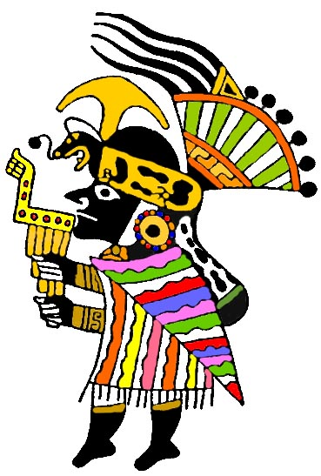
www.markamusic.com
www.markamusic.net
www.markamusic.org

MarKamusic SCHOOL PERFORMANCE INFORMATION

MarKamusic welcomes the opportunity to visit your school to share the beauty of South and Latin American music, as influenced by the passage of time and the influx of many different cultures to the continent. Your students will learn a little about history, geography, development of instruments, rhythms, harmonies and styles of music. It is an auditory delight! The following information will be useful to you regarding bringing MarKamusic to your school. MarKamusic's performances are age appropriate, and can be varied to suit grades K - 3, 4 - 6, and 7 - 12.

PERFORMANCE GOALS
• To establish "America" as North, South & Central America, not just the United States.
• Debunk ethnocentric stereotypes of what is Indigenous/native and Latino American.
• To use musical expression to bring together many diverse peoples who are tied together by
history and geography but separated by politics and language.

SOUND, SITE AND TIME REQUIREMENTS
Sound: We do not provide a P.A. sound system. If you believe that your school has an appropriate sound system, please let us know right away so that we can provide your technician with a stage diagram and minimum requirements sheet. Alternatively, MarKamusic can provide a PA system for an additional $200.00
Time: for Load-in 90 min. One hour is possible but not preferred. 30 minutes load-out is required.
Site: We will need 3 small tables (approximately 2’ x 2’ or 3' x 5’), one chair, one stool, a pitcher of water, juice or soda with ice and six glasses and snacks (If we are there over the lunch hour, lunch should be provided for up to six people. Performances are 40 min. in length and interactive workshops 40 min. in length. Interactive workshops work out better with 20-25 students, but we will tailor our presentation to your needs.

CURRENT PRICING FOR SCHOOL-DAY (NON-TICKETED) EVENTS:
For the 2007-2008 period MarKamusic's rates for school assembly programs are:
$600.00 - one interactive workshop (not including travel or P.A. system)
$750.00 - two interactive workshops in the same location (not including travel or P.A. system)
$800.00 - a single performance (not including travel or P.A. system)
$850.00 - one performance and a workshop in the same location (not including travel or P.A. system)
$900.00 - two back-to-back performances in the same location (not including travel or P.A.)
$1000.00 - two back-to-back performances plus a workshop (same location - not including travel or P.A. system)
$1200.00 - two back-to-back performances plus two workshops (same location - not including travel or P.A.
system)
$200.00 for full Public Address system rental used for concerts.
$100.00 for a small Public Address system rental used for workshops.

*Concerts for schools are significantly lower than MarKamusic's normal concert fee, which is in the $2500 - $5000 range. A school concert performed in a central location with two or more schools sharing the fee is priced as a single performance in the same location ($850.00).

*Travel fee will be charged only if your school is outside the one-hour driving range from the Amherst, MA. area. The travel rate is 15 dollars for each five extra miles driven (getting there and coming back) beyond the 60 mile/1 hour Amherst, MA. radius.

