Causa Limeña

The word Causa derives from the Quechua word kausay, which means 'sustenance of life'.
the Andean Indians consumed this wonderful dish before the European invasion preparing it simply with mashed boiled potato eaten with ají (hot peppers), combining in this way two staple Andean crops: potatoes and hot peppers.

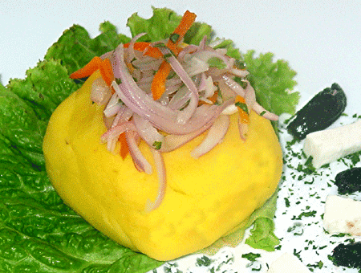
Ingredients
Enough for 8 people as an appetizer
45 minutes to make

- 2 ½ lbs Yukon potatoes (only these will work well)
- Juice of 3 very large limes or 4 medium size
- 1 cup chopped cilantro
- 4 tablespoons or ¼ cup of extra virgin olive oil
- 2 ½ teaspoons sea salt
- ½ teaspoon ground annatto (for lack of yellow ají)
- 1 teaspoon ground black pepper
- 2 cloves of garlic
- 3 boiled eggs cut in 4ths length wise.
- 10 leafs of any kind of lettuce
- Onion Sauce or Avocado Mayo or Cilantro Mayo (find these recipes in this page web too)
- Some 20 olives of any kind (Black Peruvian Botija, kalamata or Moroccan olives are the best)

Preparation
Micronuke potatoes on high three at a time wrapped in a wet towel. Or boil if an eco-freak and lose in the water all the goodness that potatoes have to offer you. If you are nuking your potatoes to keep all their vitamins and goodness it is best to use medium sized potatoes and nuke them on high for about 4 to 6 minutes depending on your microwave. Always remember to turn potatoes upside down at half the cooking time. While your potatoes are cooking, blend all cilantro, salt, pepper, annatto, olive oil, garlic and lime juice together. Set aside for later. When potatoes are very soft mash them right away (it is easy to mash them while they are hot). Then pour all the other ingredients previously blended over mashed potatoes and work this liquid in with your hands as if kneading bread dough. Once all ingredients are well mixed shape potatoes as a loaf of bread. Pour Onion Salad or Avocado Mayo or Tuna Mayo on potato dough (you may actually use all of these if you stack them in layers. Do it this way: divide potatoes in 3 and then form 3 layers with a different topping on each for a stunningly delicious Party Causa) Slice in 2” slices as if serving cake. Serve over a leaf of lettuce and garnish with a couple olives and ¼ of a boiled egg.

Got any questions? Call me please: 413-549-9155 and ask for Freddy

