Fried Yucas (Yuca frita)
Yuca, cassava or manioc is a tubercle endemic to the subtropical South American region (Southern Brazil, Argentina and Paraguay). Known varieties are thought to be the product of human intervention and manipulation. There is archeological evidence that it was systematically cultivated in Peru more than 4.000 years ago. Indeed it was one of the first domesticated crops in the Peruvian Andes. You may never want to eat French fries ever again after you try these…

Ingredients

2 Lbs of fresh or frozen yucas
½ cup of canola oil (it’s best for you…trust me)
3 tablespoons of cider vinegar (also best for you…trust me again I am not a politician)
6 cups of water (vegetable or chicken broth also work! then you’ll have a super delicious thick
broth to which you can add a little or a lot of cilantro to enjoy later with your yucas)
3 teaspoons sea salt
6 leafs of paper towels

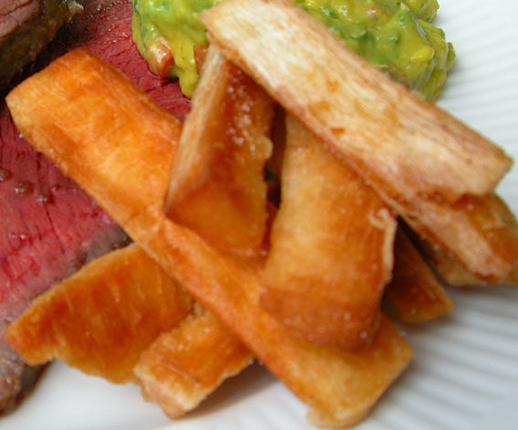

Preparation
Peel yucas and wash in cold water (they have a hard dark brown peel that always comes covered in wax to protect freshness – according to merchants). If you chose the frozen variety they will already be peeled and clean. Put yucas with all water (or broth), vinegar and 2 teaspoons of salt in pot, preferably in a pressure cooker for about 25 minutes, or about 1 hour plus if using a regular cooking pot. When yucas are soft to the core they are ready to be fried. Retire from water and put on half of paper towels to dry a little. Remove now the stringy coarse core of yucas. They are easy to take off just by pulling out softly. Now, slice yucas length wise with a thickness of about ½ inch. Put all oil in frying pan at medium high heat. Fry yucas until golden, golden brown or light brown. Some people like me, prefer them darker. I prefer them on the light brown side - they’ll be very crunchy this way. Put them on remaining paper towels and sprinkle with left over salt. Enjoy with at least two friends or family!

