Peruvian Ceviche

Ingredients:

- The juice of 15 extra large limes (the more acidic the better)
- 2 large red onions thinly sliced against the grain
- 1 ½ cups of chopped cilantro
- 4 teaspoons of sea salt (yeah it needs that much to counter act the acidity of the lemons)
- 1 teaspoon of freshly ground black pepper
- 2 red Serrano peppers (for taste and heat) or replace with a not so hot pepper variety
- 1 Lb Sweet potatoes
- 2 ears of corn boiled and sliced in 2” rounds
- 2 Lbs fish filets (works best with sword fish, striped sea bass and corvina (drum or croaker fish)- imported from Peru or Chile - or tilapia for an economic choice. Any other type of fish just won’t be the same. Many times I have been told that fish and sea food are wonderful in North America but I suggest you decide after you have tried the fish and sea food from the south pacific. It has nothing to do with stupid nationalism or regional pride. You see, it is just a simple physical phenomenon. The ocean is phito-plankton rich in the south. Plankton are actually living organisms that other fish eat. Just like grapes for wine and olives for olive oil are better from certain regions of the world, the same is for sea food, Hello!!!)
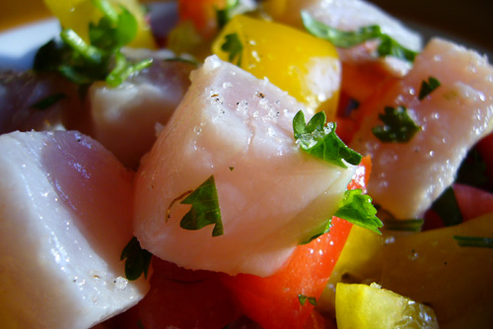

Preparation:
First wash fish in cold water. Then cut it in small strips or squares about 1 ½ ” X ½ ”. Put in a bowl and add onions, cilantro, pepper and salt in that order. Finally, add lime juice. Mix well and let stand for at least ½ hour until you see the fish turning a white milky, watery color. Re-season with more salt if necessary. While ceviche is cooking, wash sweet potatoes with cold water and then boil them in 6 cups of water with the 3 tablespoons of brown sugar for about 40 minutes or until soft to the core. Let cool. Peel and cut sweet potatoes in 2” rounds. For serving your ceviche, place a piece of sweet potato in the center of the plate and pour ceviche with juice on top of it. Garnish with rounds of boiled corn on the cob.
Good enough for 6 people if a main dish or 10 people if used as an appetizer.

