Salsa de Cebollas (Red Onion salad)

This typical Peruvian sauce is used as an accompaniment for beans, boiled potatoes, boiled yucas, fried pork, etc.

Ingredaments (as Rabbit would say)

- 2 Large red onions thinly sliced against the grain (only use red onions for this sauce)
- 2 teaspoons sea salt
- 1/2 teaspoon freshly ground black pepper
- 2/3 cup of chopped cilantro (when chopping cilantro only discard the bottom end close to the roots. You really can use all of the stems exception made of the roots)
- Juice of 3 large limes or 3 tbsp. cider vinegar (though in Peru many would also use white vinegar)
- 1 tablespoon of a good extra virgin olive oil (or you can do it without the oil)
- 1 Serrano pepper thinly sliced (if you like your salsa to be hot)
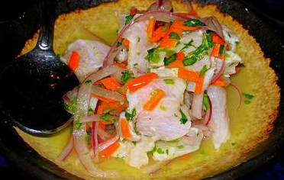

Preparation
First put Onions in a deep bowl, then add cilantro, oil (if using), salt, ground pepper, hot pepper (if using) and lime juice (or vinegar). Do it in that order please. Stir a bit and let stand for about 15 minutes.
Pour on top of boiled Yucas or use to make Causa Limeña (also look for Causa dish on this web site), accompany boiled potatoes or with cooked beans.

